School Name
Mathematics Test 2017
Year 10 |  | Linear Relations | Non Calculator
Skills and Knowledge Assessed:  - Sketch linear graphs using the coordinates of two points and solve linear equations (ACMNA215)  - Solve problems involving parallel and perpendicular lines (ACMNA238) |  |  | Name_________________
Section 1 Short Answer Section
Write all working and answers in the spaces provided on this test paper.

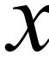 | 1 | 2 | 4 | 5
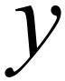 |  | –6 |  | 3

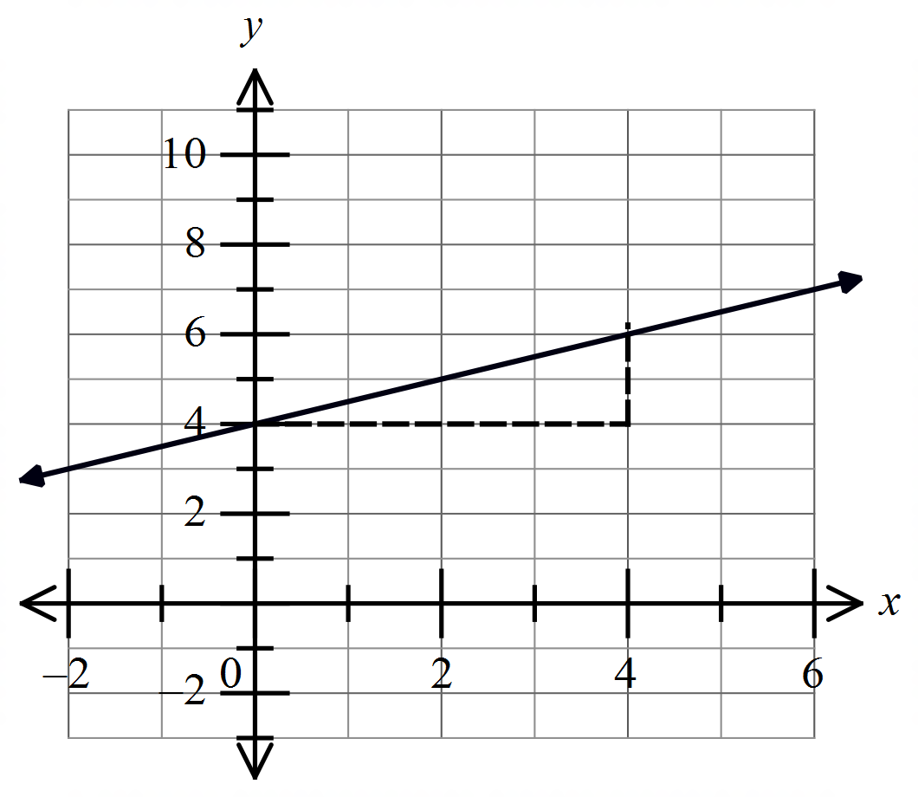What is the gradient of the line shown below?

………………………………………………

……………………………………………....

………………………………………………

……………………………………………….
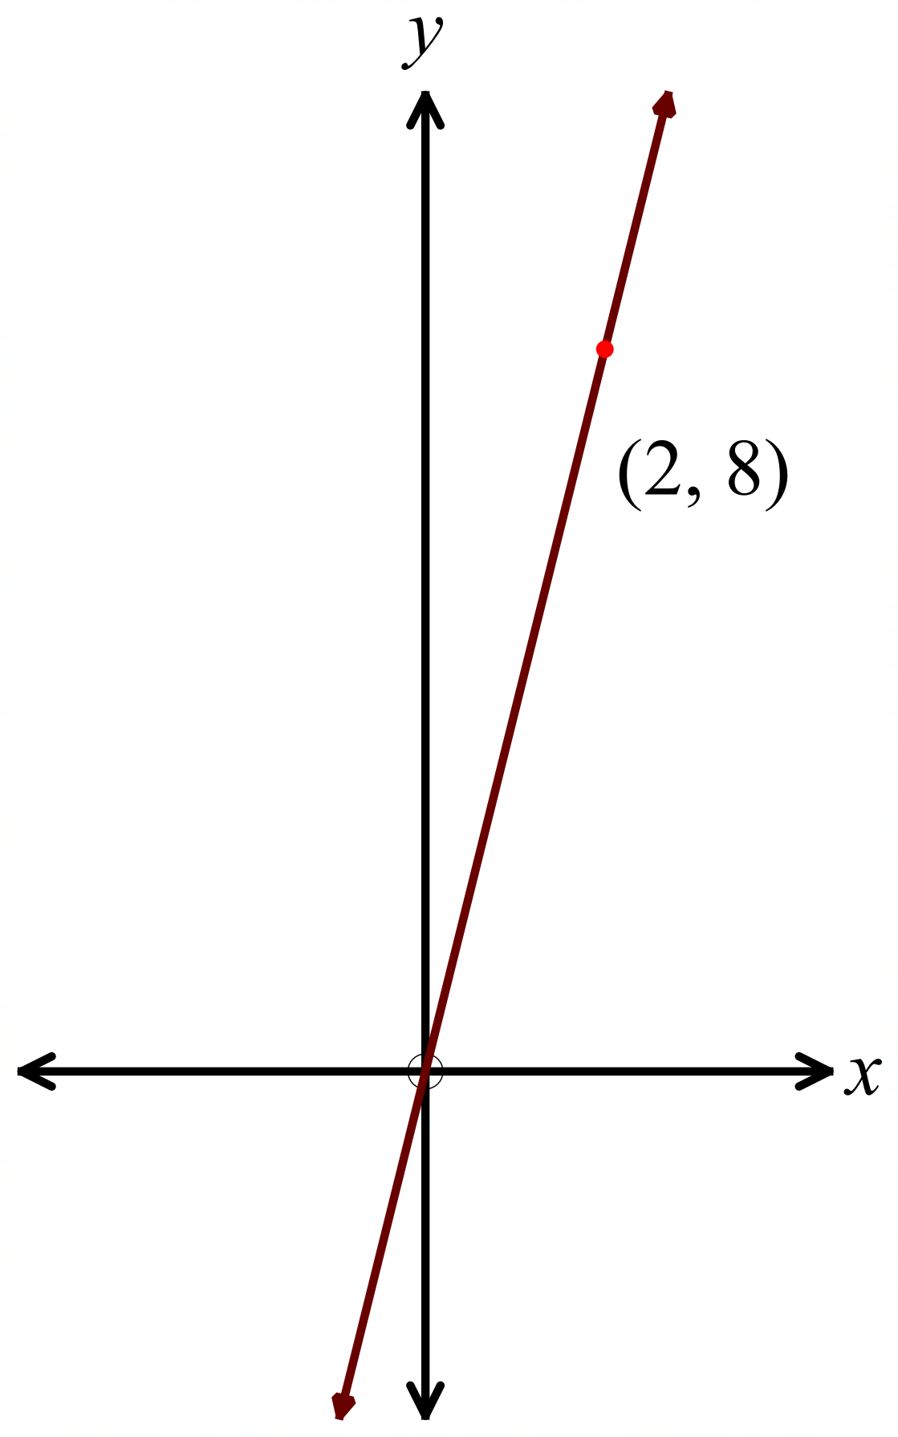What is the equation of the line shown?

…………………………………………

………………………………………….

…………………………………………

………………………………………………………………………………………………………

………………………………………………………………………………………………………
A line on the number plane has a gradient of –4 and crosses the y axis at y = –9.

What is the equation of the line?

………………………………………………………………………………………………………

………………………………………………………………………………………………………
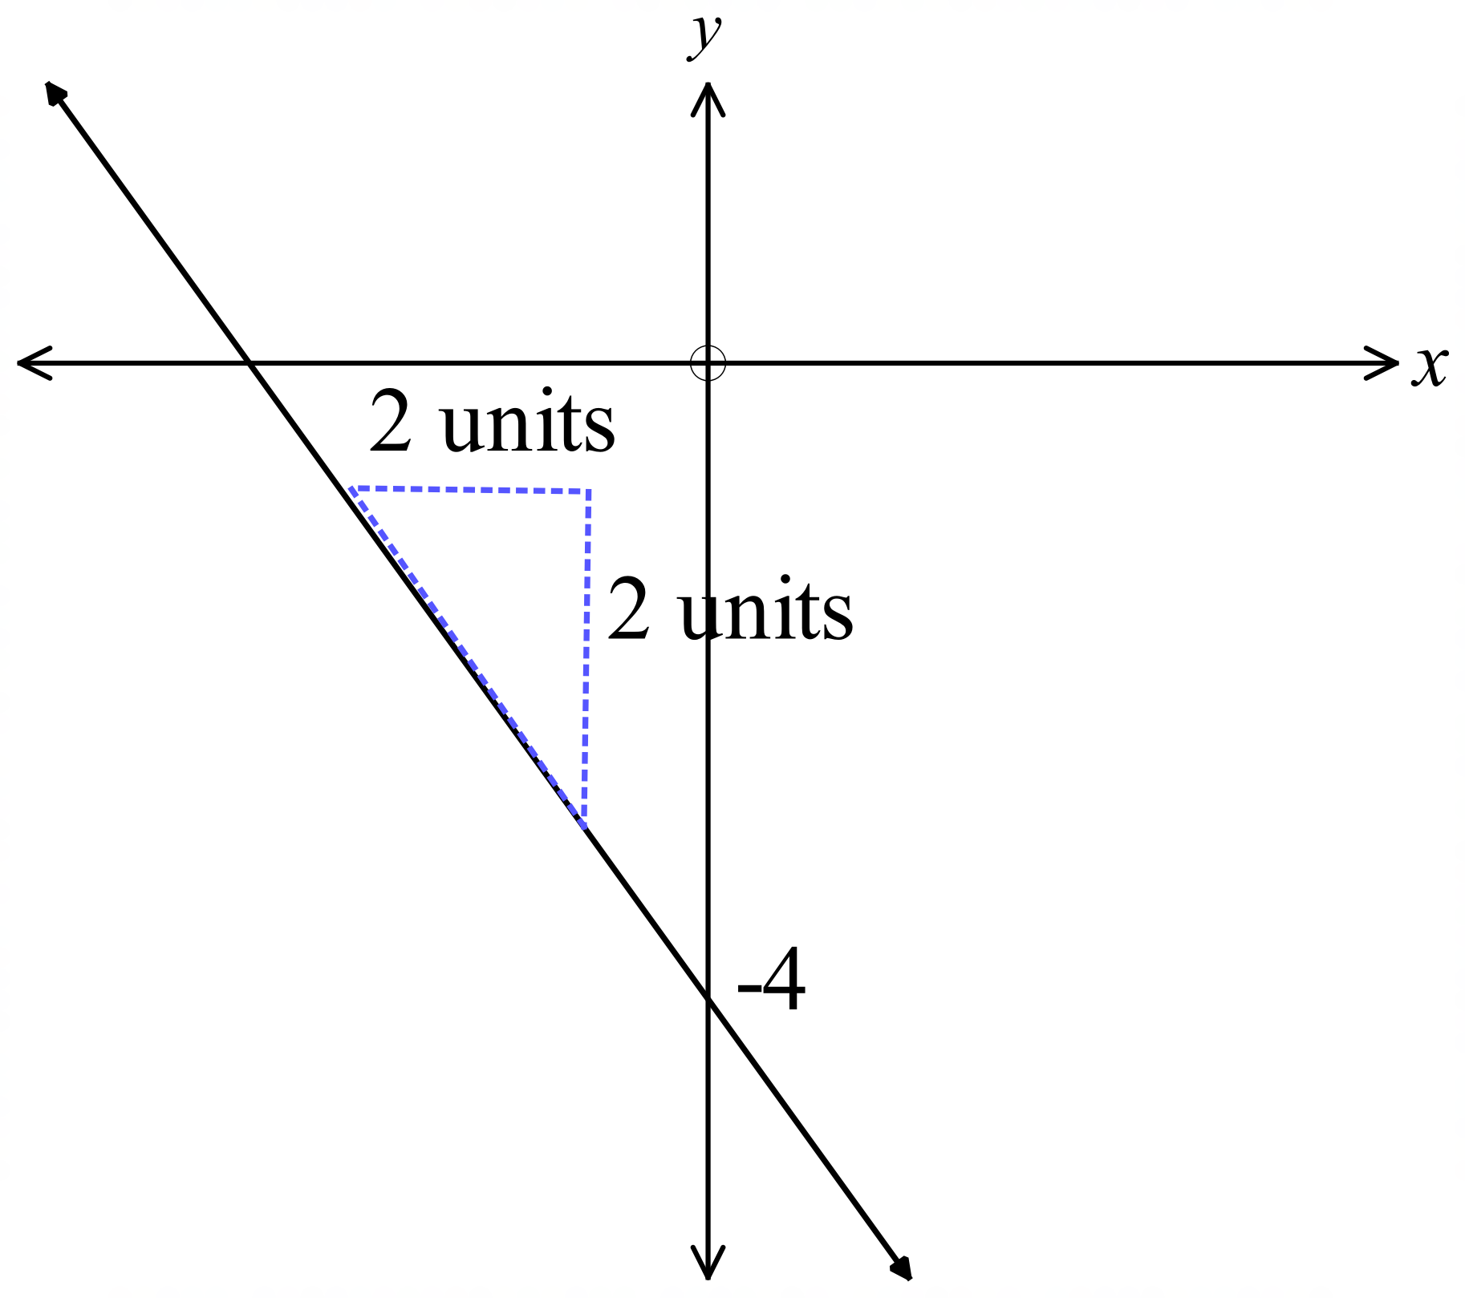What is the equation of the line shown?
.....................................................................

.....................................................................

.....................................................................

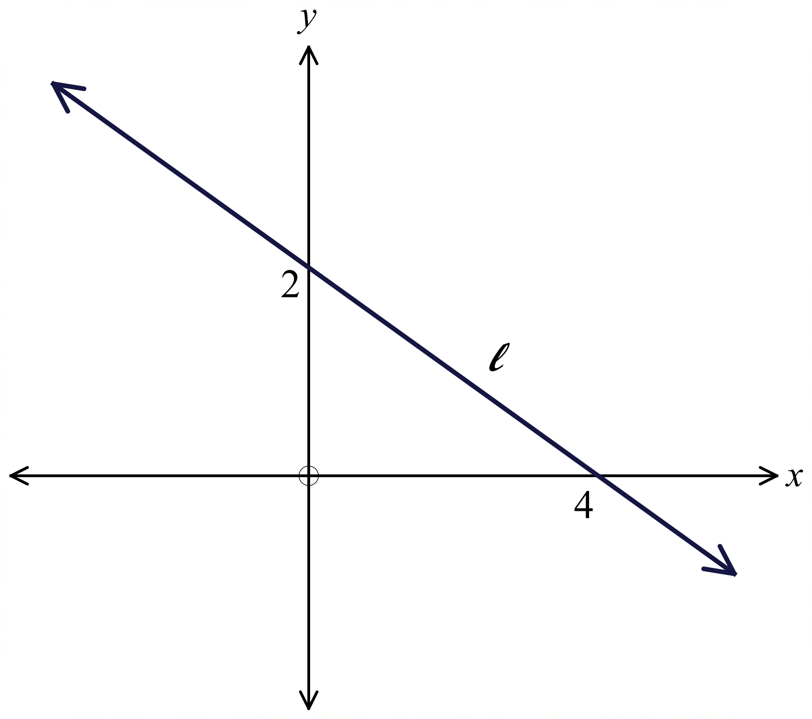The line l crosses the y axis at 2 and the x axis at 4.
What is the equation of the line l ?
.....................................................................

.....................................................................

.....................................................................

.....................................................................
A straight line that passes through the point (–3, 7) has a gradient of –8.
What is the equation of the line?

……………………………………………………………………………………………….

……………………………………………………………………………………………….
The line q is perpendicular to the line 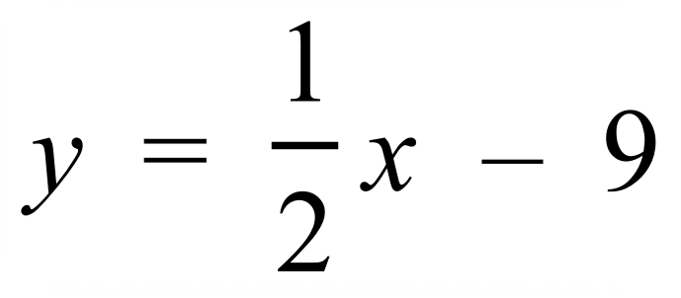.
What is the gradient of the line q?

……………………………………………………………………………………………….

……………………………………………………………………………………………….

……………………………………………………………………………………………….

……………………………………………………………………………………………….
A horizontal line on the number plane passes through the point (–7, 9).
What is the equation of the line?

………………………………………………………………………………………………………

………………………………………………………………………………………………………
A straight line passes through the points 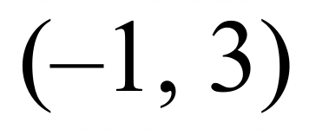 and (4, 13).
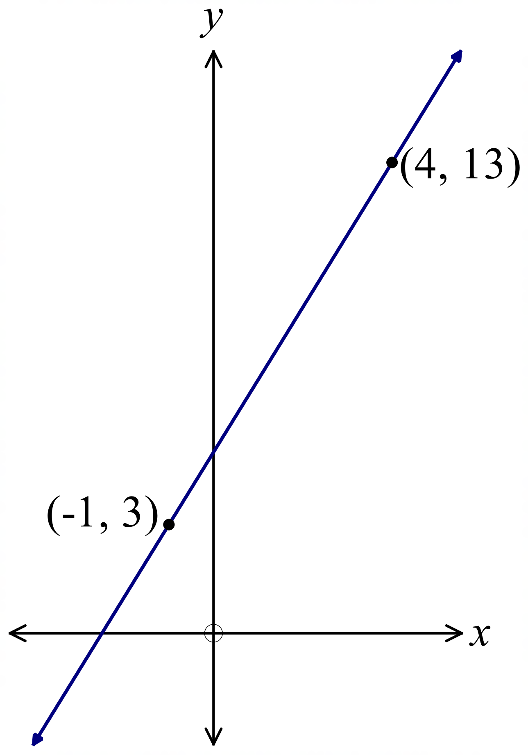What is the equation of the line?

.....................................................................

.....................................................................

.....................................................................

.....................................................................

A straight line on a number plane has an equation of 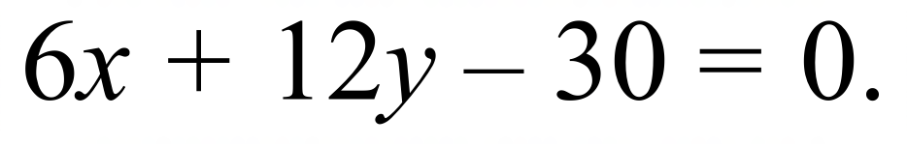
What is the gradient of the line?

……………………………………………………………………………………………….

……………………………………………………………………………………………….
The line l is parallel to the line 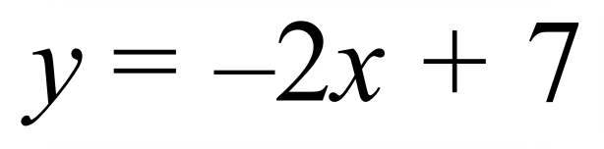 and has an x intercept at x = 8.
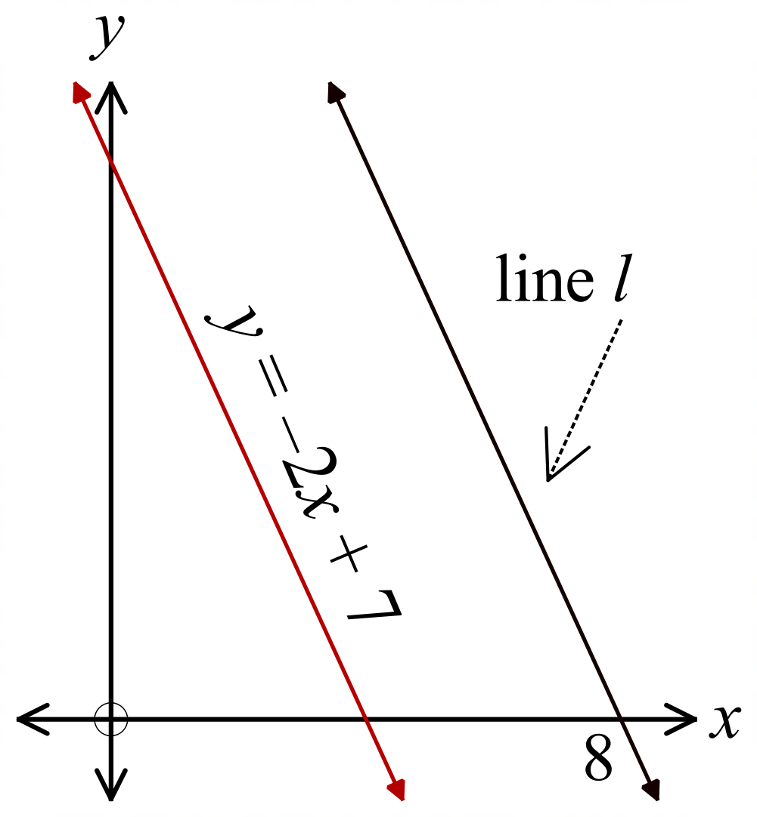The equation of the line l, is:

…………………………………………

………………………………………….

…………………………………………
Find the equation of the line which is parallel to the line 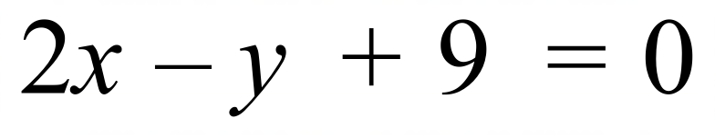 and passes through (–4, 6).

……………………………………………………………………………………………….

……………………………………………………………………………………………….

……………………………………………………………………………………………….

……………………………………………………………………………………………….
Find the equation of the line which is perpendicular to 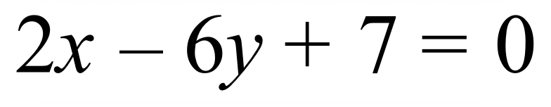 and passes through the point (–5, 3).

……………………………………………………………………………………………….

……………………………………………………………………………………………….

……………………………………………………………………………………………….

……………………………………………………………………………………………….

School Name
Mathematics Test 2017
Year 10 |  | Linear Relations | Calculator Allowed
 |  | Linear Relations | Name_________________
Section 2 Multiple Choice Section
Mark all your answers on the accompanying multiple choice answer sheet, not on this test paper. You may do any working out on this test paper. Calculators are allowed for this section.

A line on the number plane has an equation 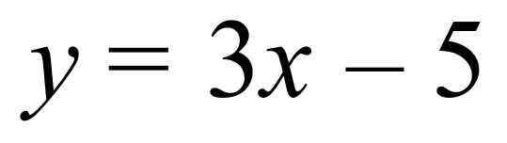 .
What is its gradient?
A. –5 B. –3 C. 3 D. 5

 | 0 | 2 | 4 | 6
 | –6 | ? | 14 | 24

A. –4 B. 4 C. 6 D. 10
A line has a gradient of –2 and passes through the point (0, –5).
What is its equation?
A. 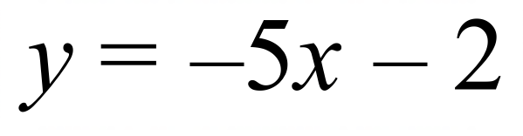
B. 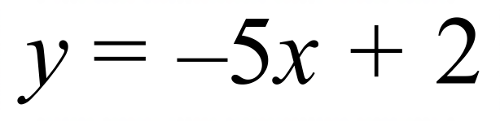
C. 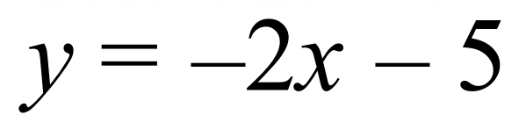
D. 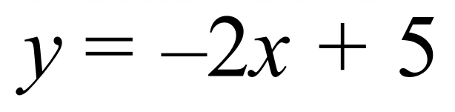
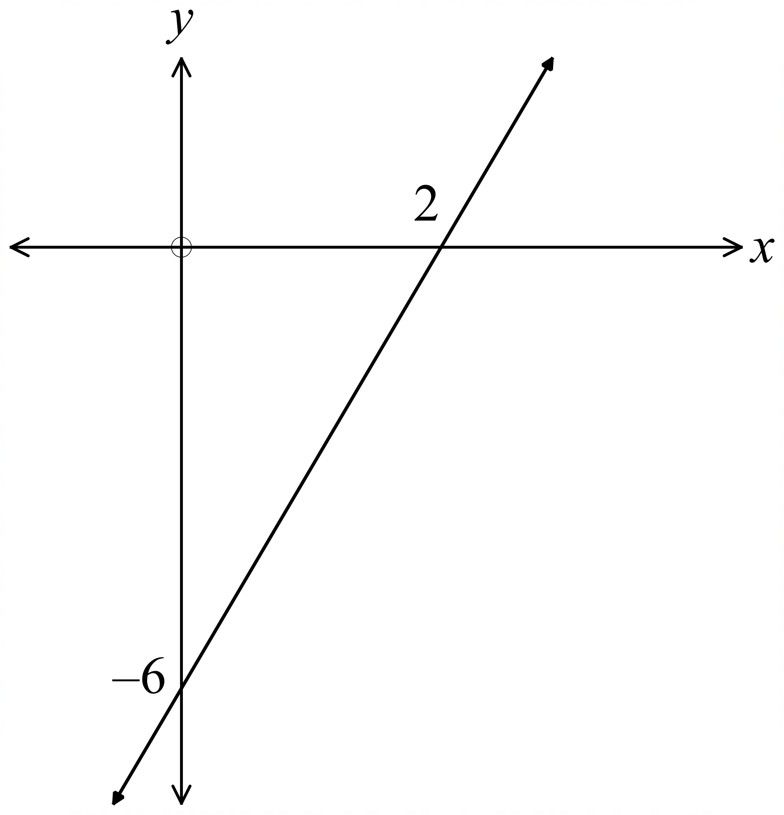The equation of the line shown is:

A. 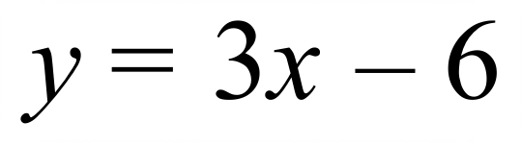

B. 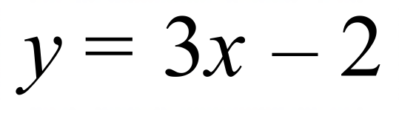

C. 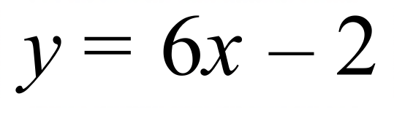

D. 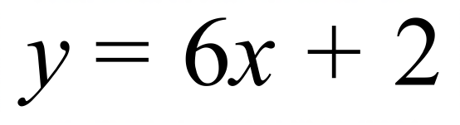

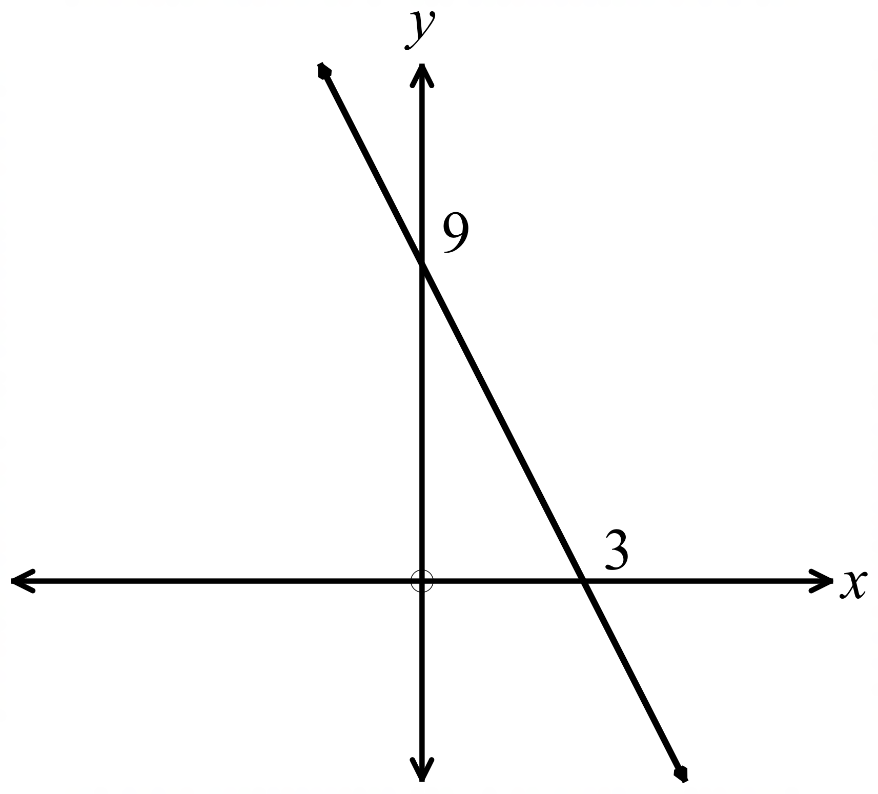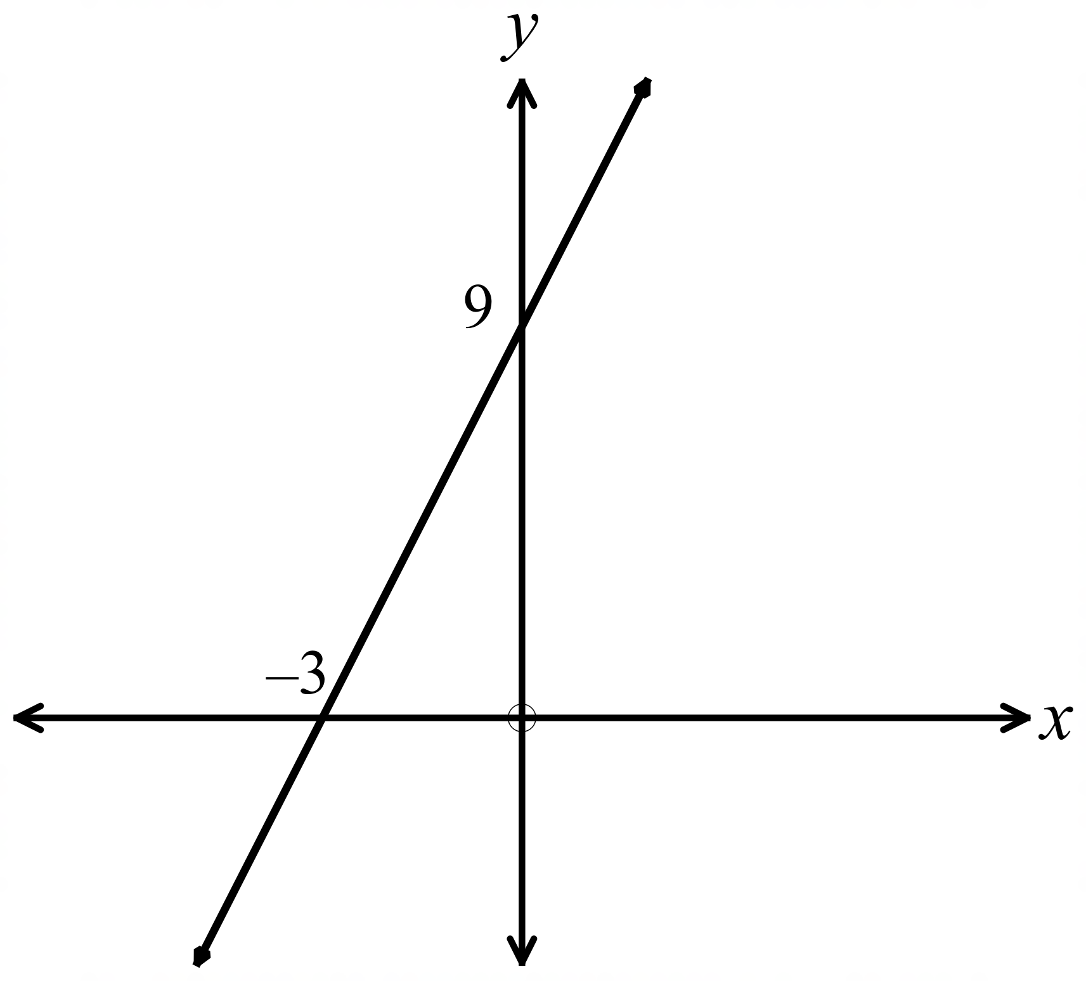 A. B.

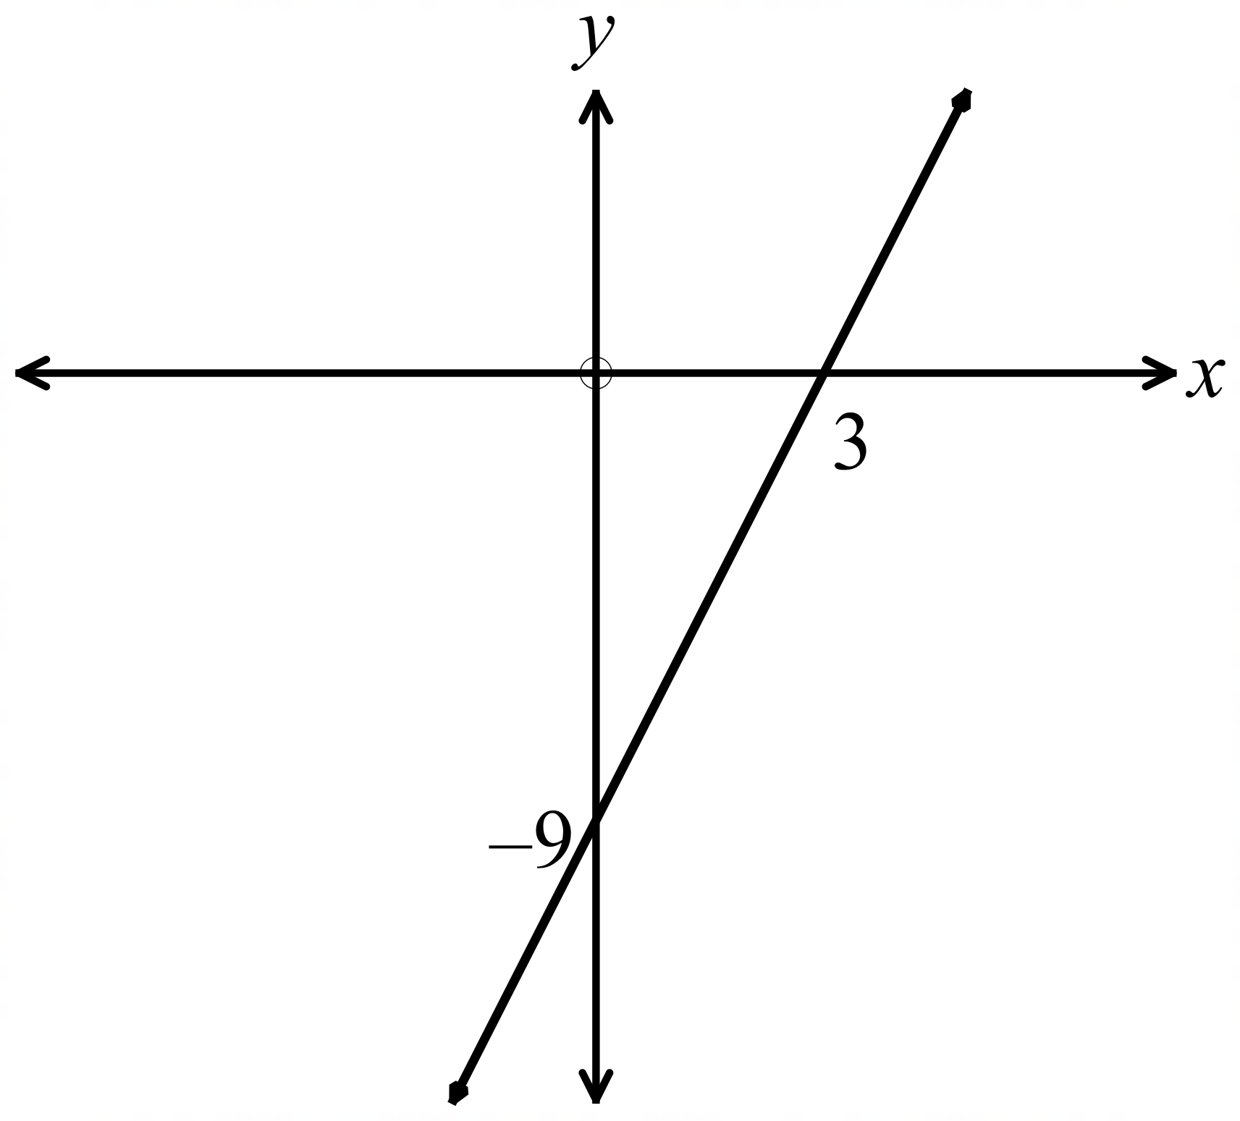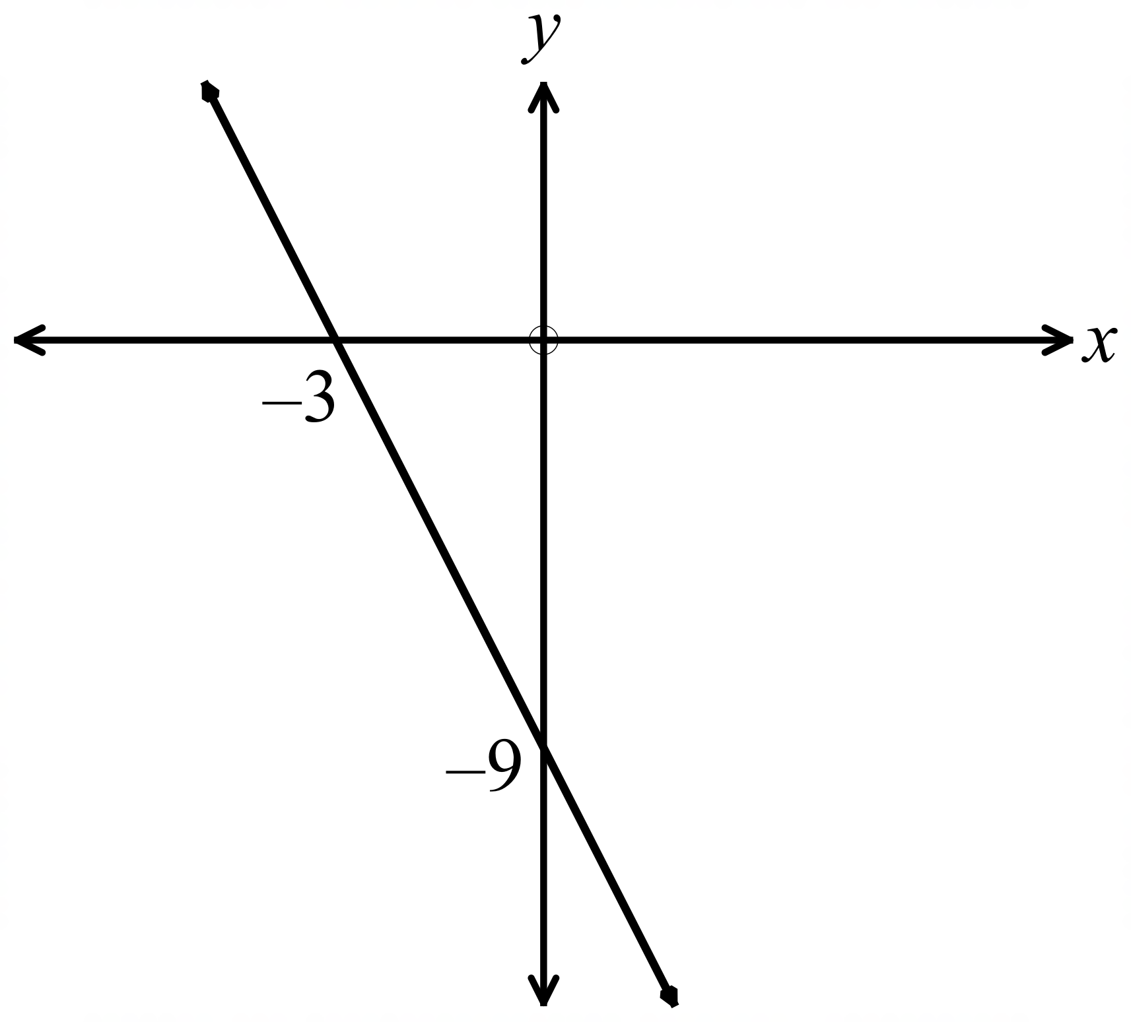
C. D.

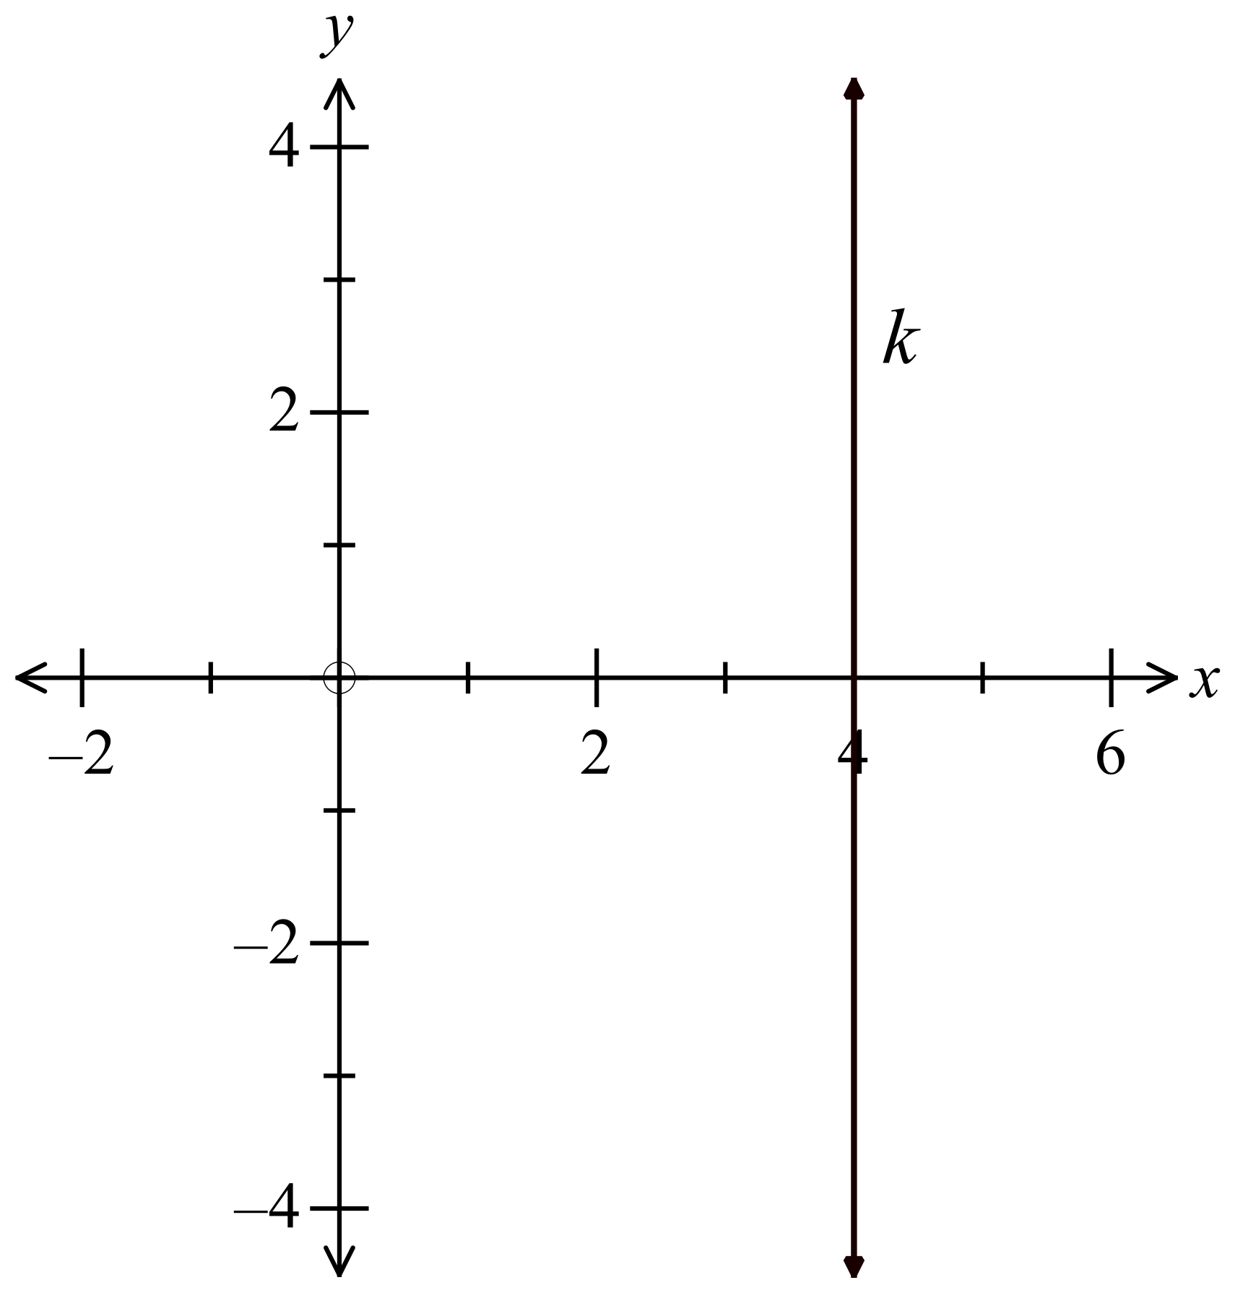The line k is shown on the number plane to the right.
The equation of the line k, is:

A. 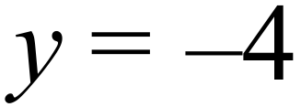
B. 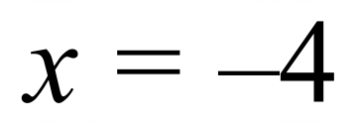
C. 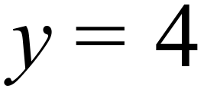
D. 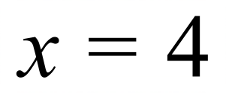

A line has a gradient of –6 and passes through the point (–5, 3).
What is its equation?

A. 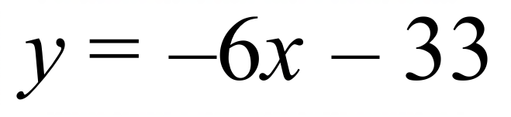

B. 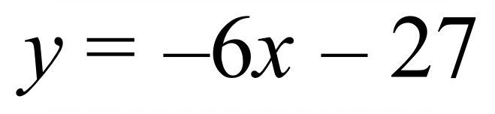

C. 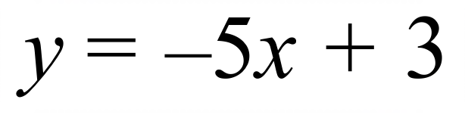

D. 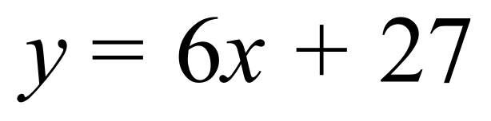

Which line does not contain the point (–2, –6) ?

A. 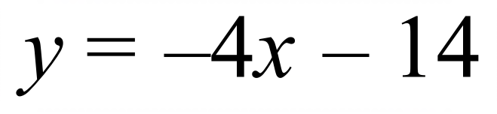 B. 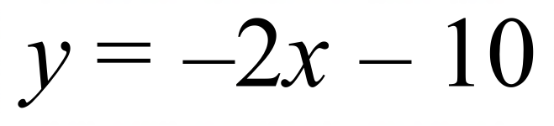
C. 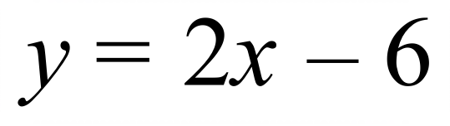 D. 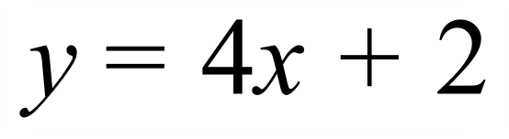

Which is the graph of the line 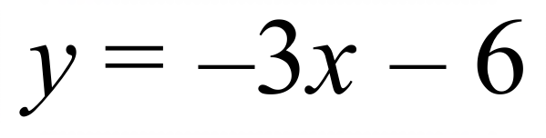 ?
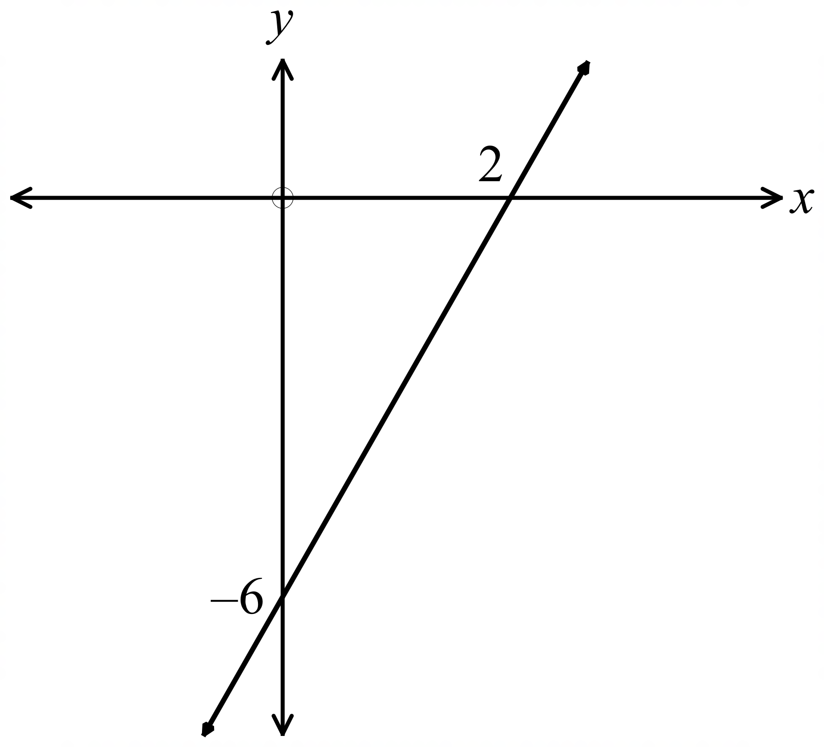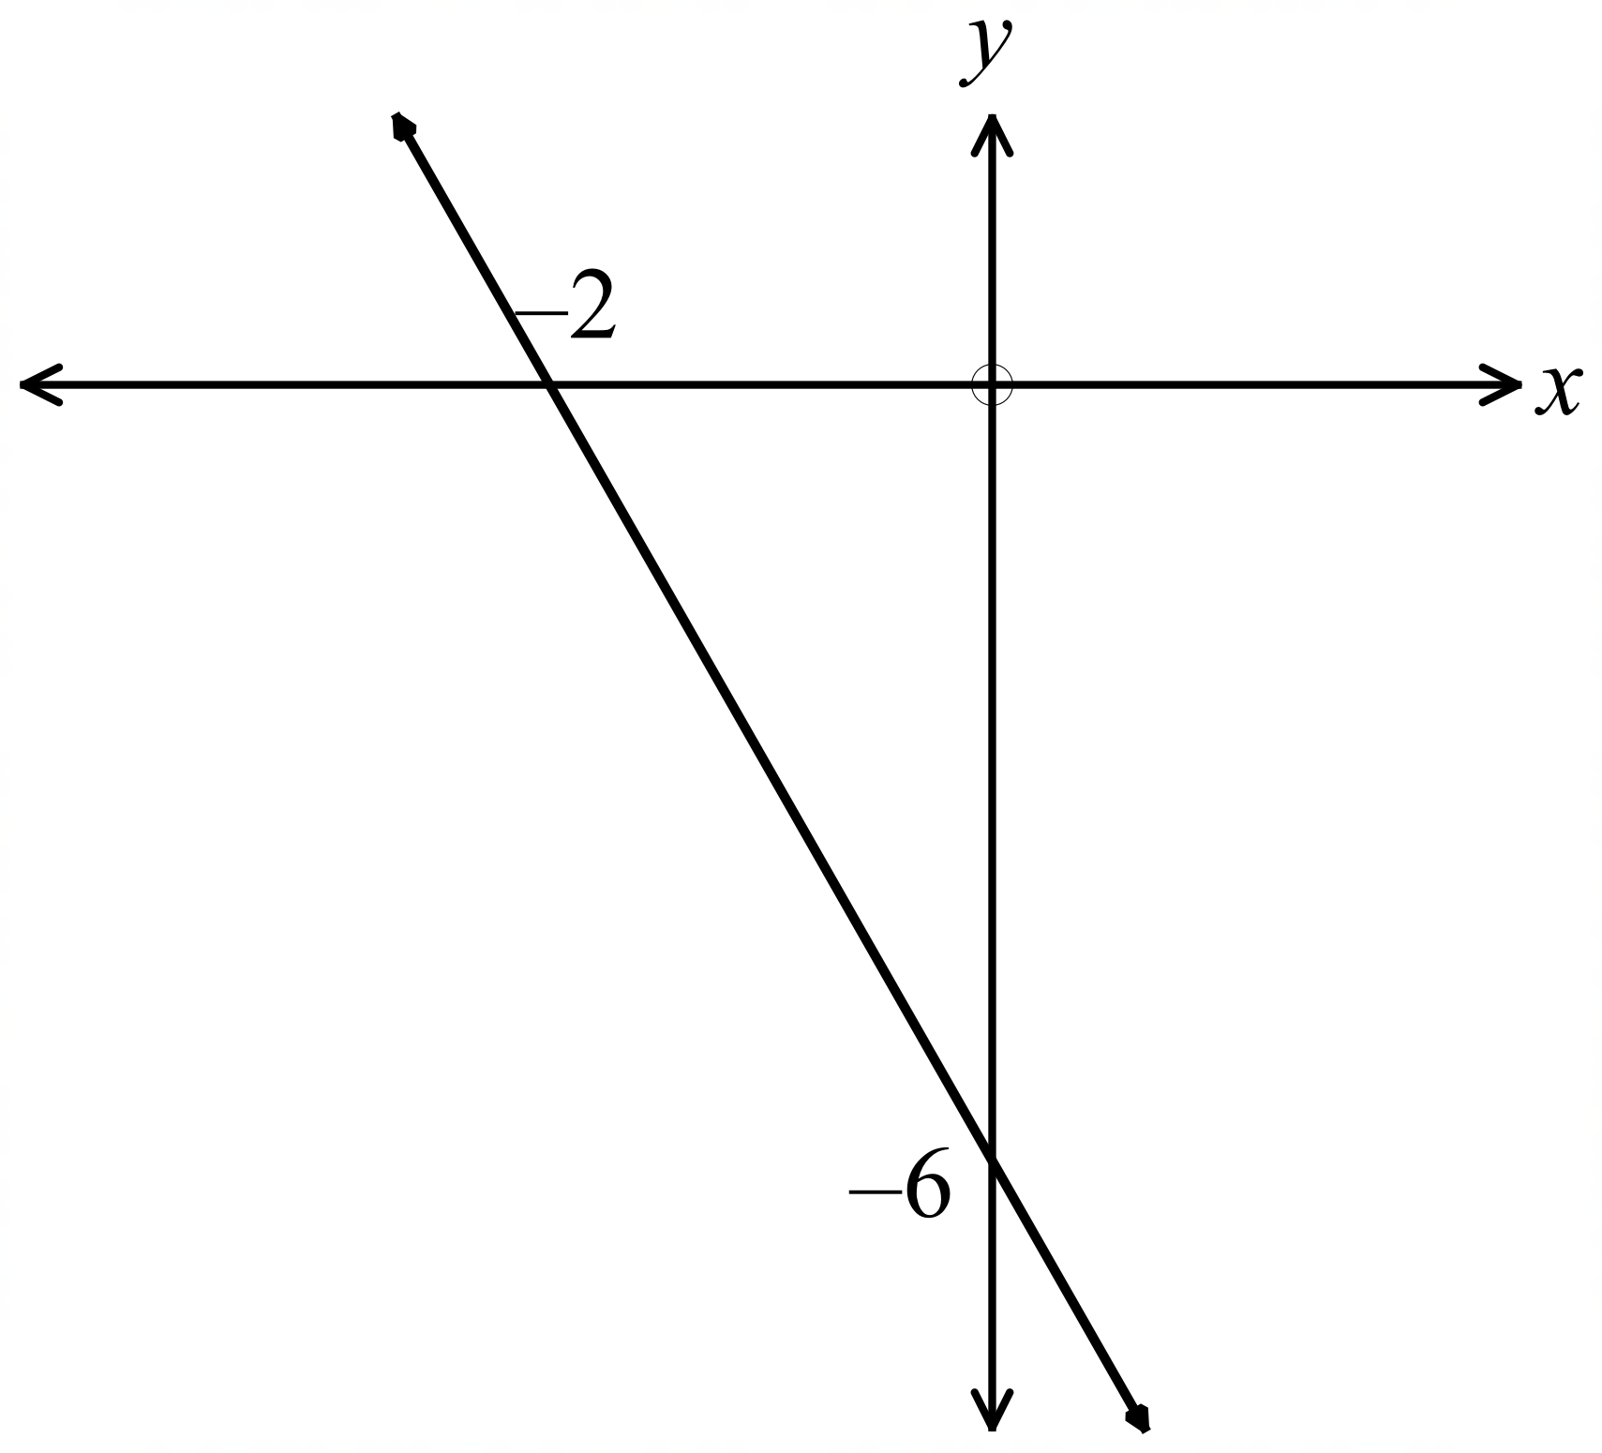
A. B.

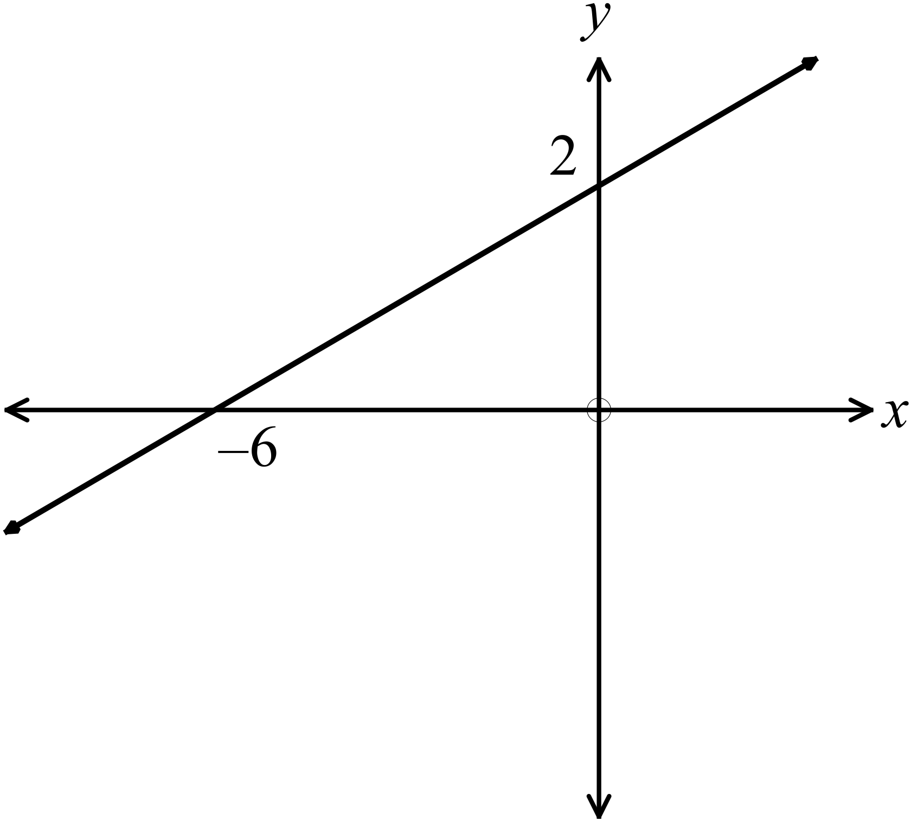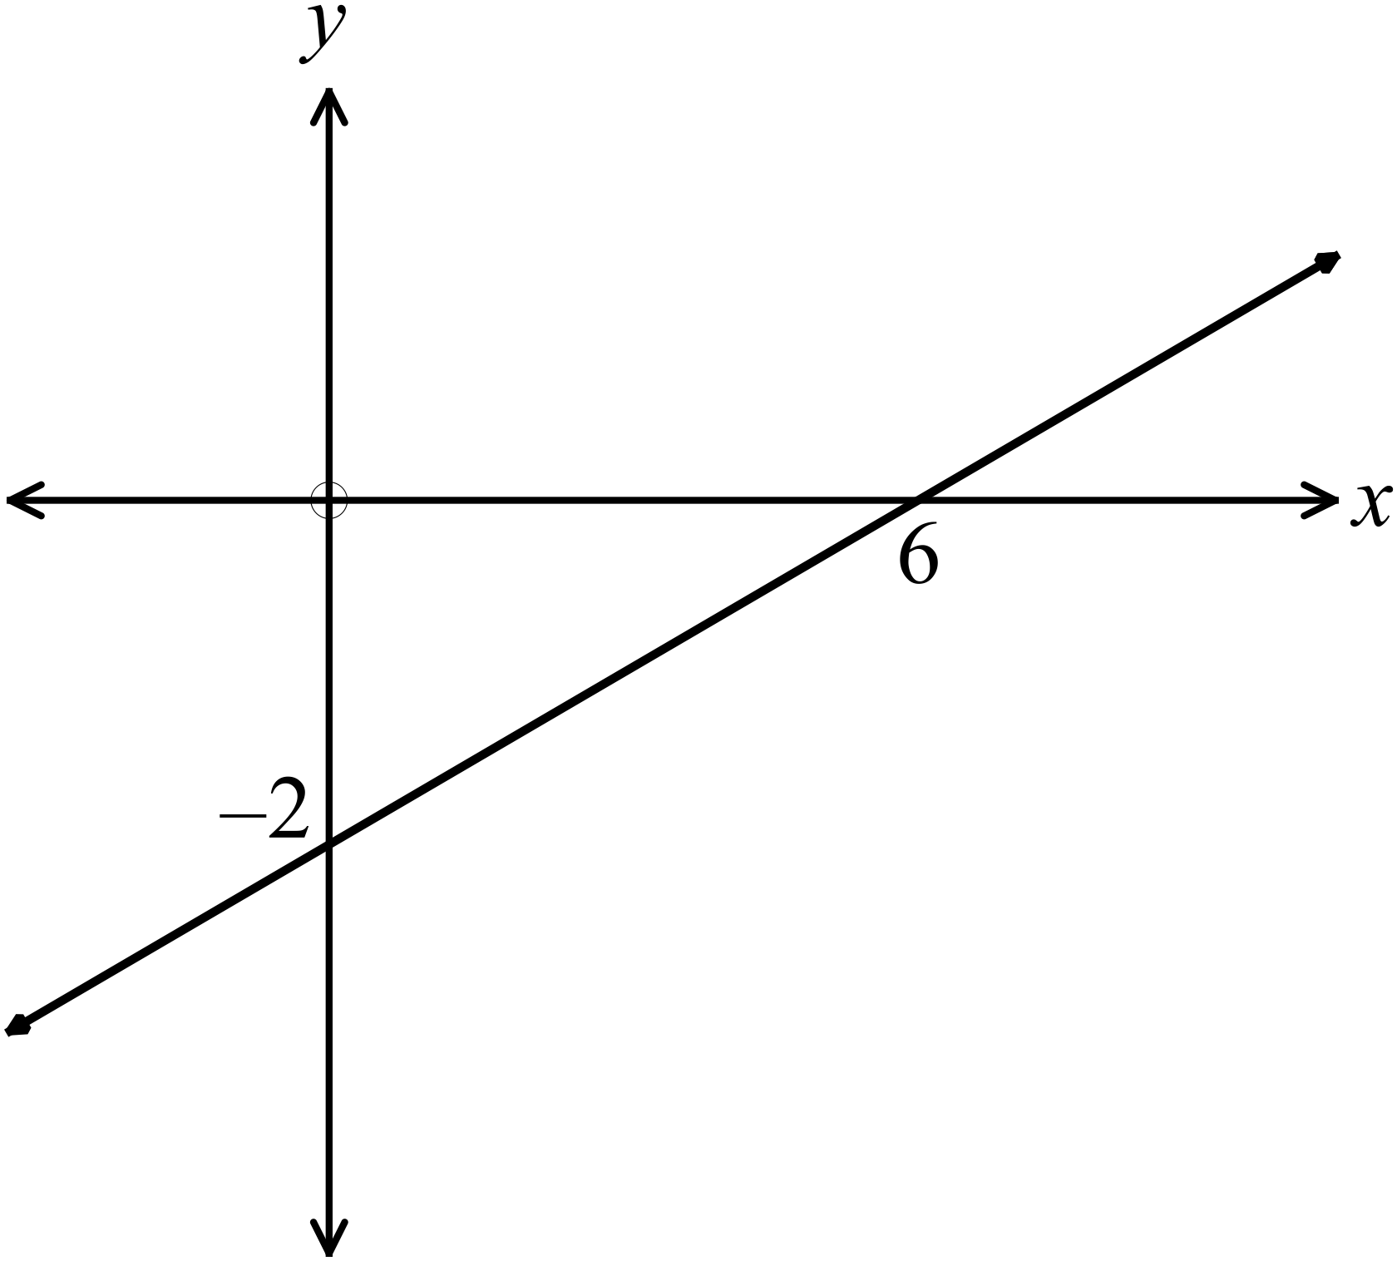 C. D.

Which of these lines is perpendicular to the line 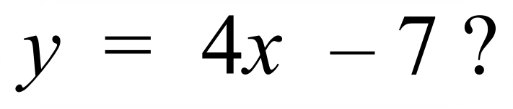 ?

A. 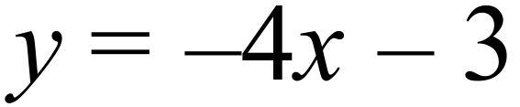 B. 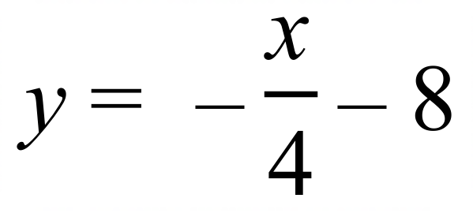 C. 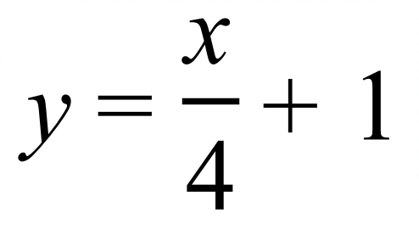 D. 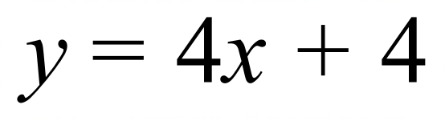
A line has equation 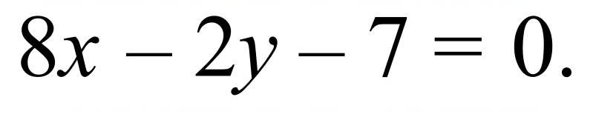 Which statement is true?

A.
B.
C. 
D.
What is the equation of the line which passes through the points (3, –7) and (–1, 1)?

A. 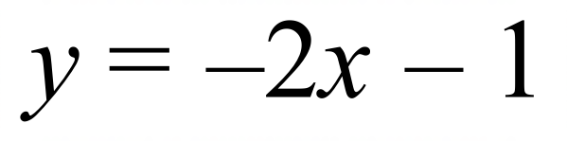 B. 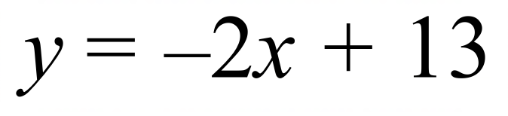

C. 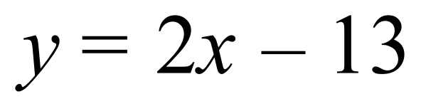 D. 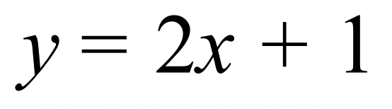
Line j has its equation : 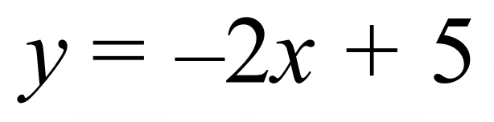
Line k has its equation : 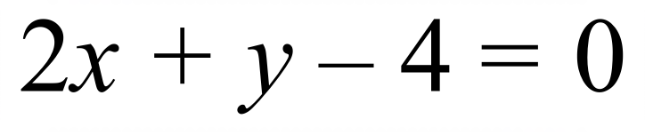
Line l has its equation : 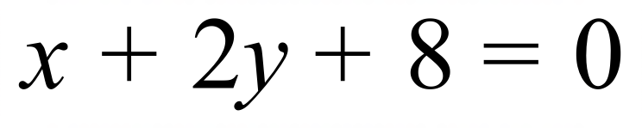

Which statement is true?

- Line j is perpendicular to line k.

- Line j is parallel to line k.

- Line k is perpendicular to line l.

- Line k is parallel to line l.

Which line is perpendicular to 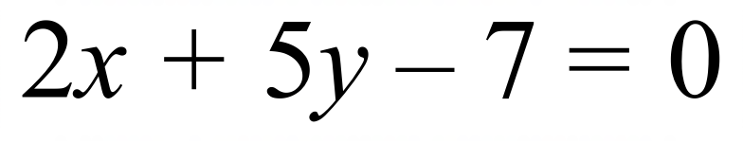 ?

A. 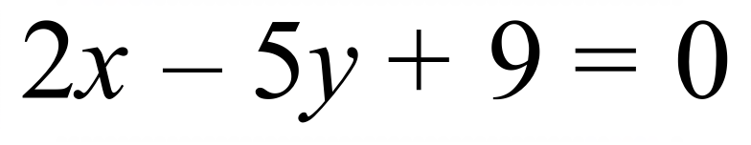 B. 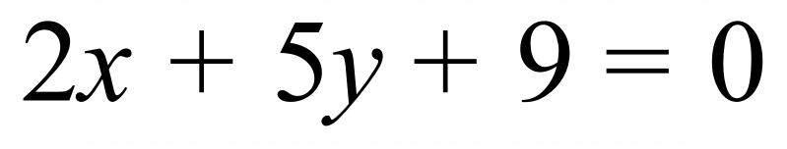

C. 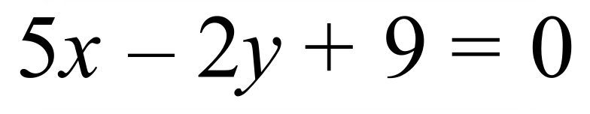 D. 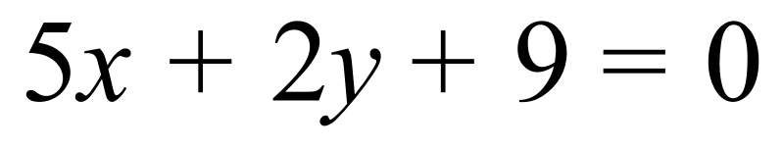
The line l passes through the point (–2, 10) and is perpendicular to the line 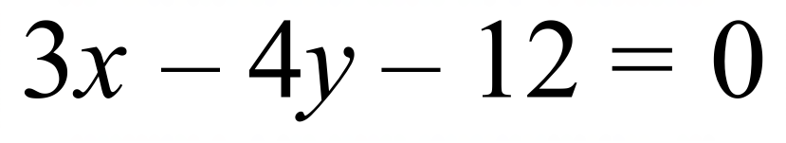.
What is the equation of the line l ?

A. 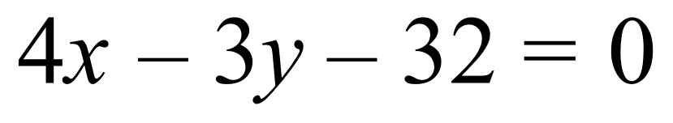

B. 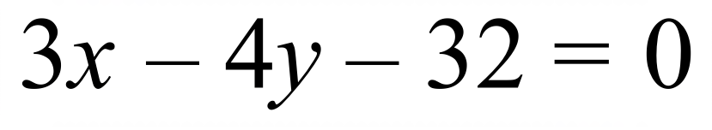

C. 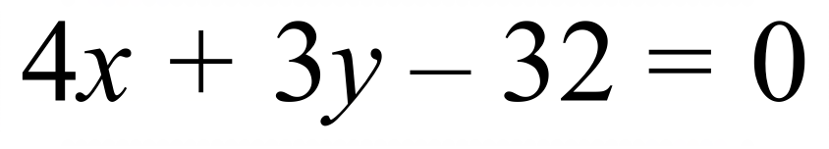

D. 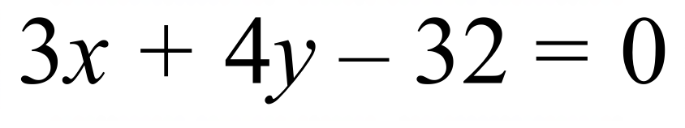

School Name
Mathematics 2017
Multiple Choice Answer Sheet
Linear Relations
Name _____________________________________________
Completely fill the response oval representing the most correct answer.
1. A B C D
2. A B C D
3. A B C D
4. A B C D
5. A B C D
6. A B C D
7. A B C D
8. A B C D
9. A B C D
10. A B C D
11. A B C D
12. A B C D
13. A B C D
14. A B C D
15. A B C D

School Name
Mathematics Test 2017
Year 10 | Linear Relations | Non Calculator Section
ANSWERS

Question | Working and Answer
 | 1 | 2 | 4 | 5
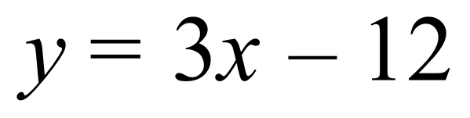 | –9 | –6 | 0 | 3

 | 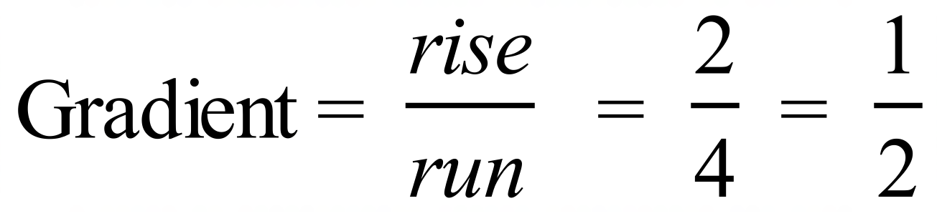
 | 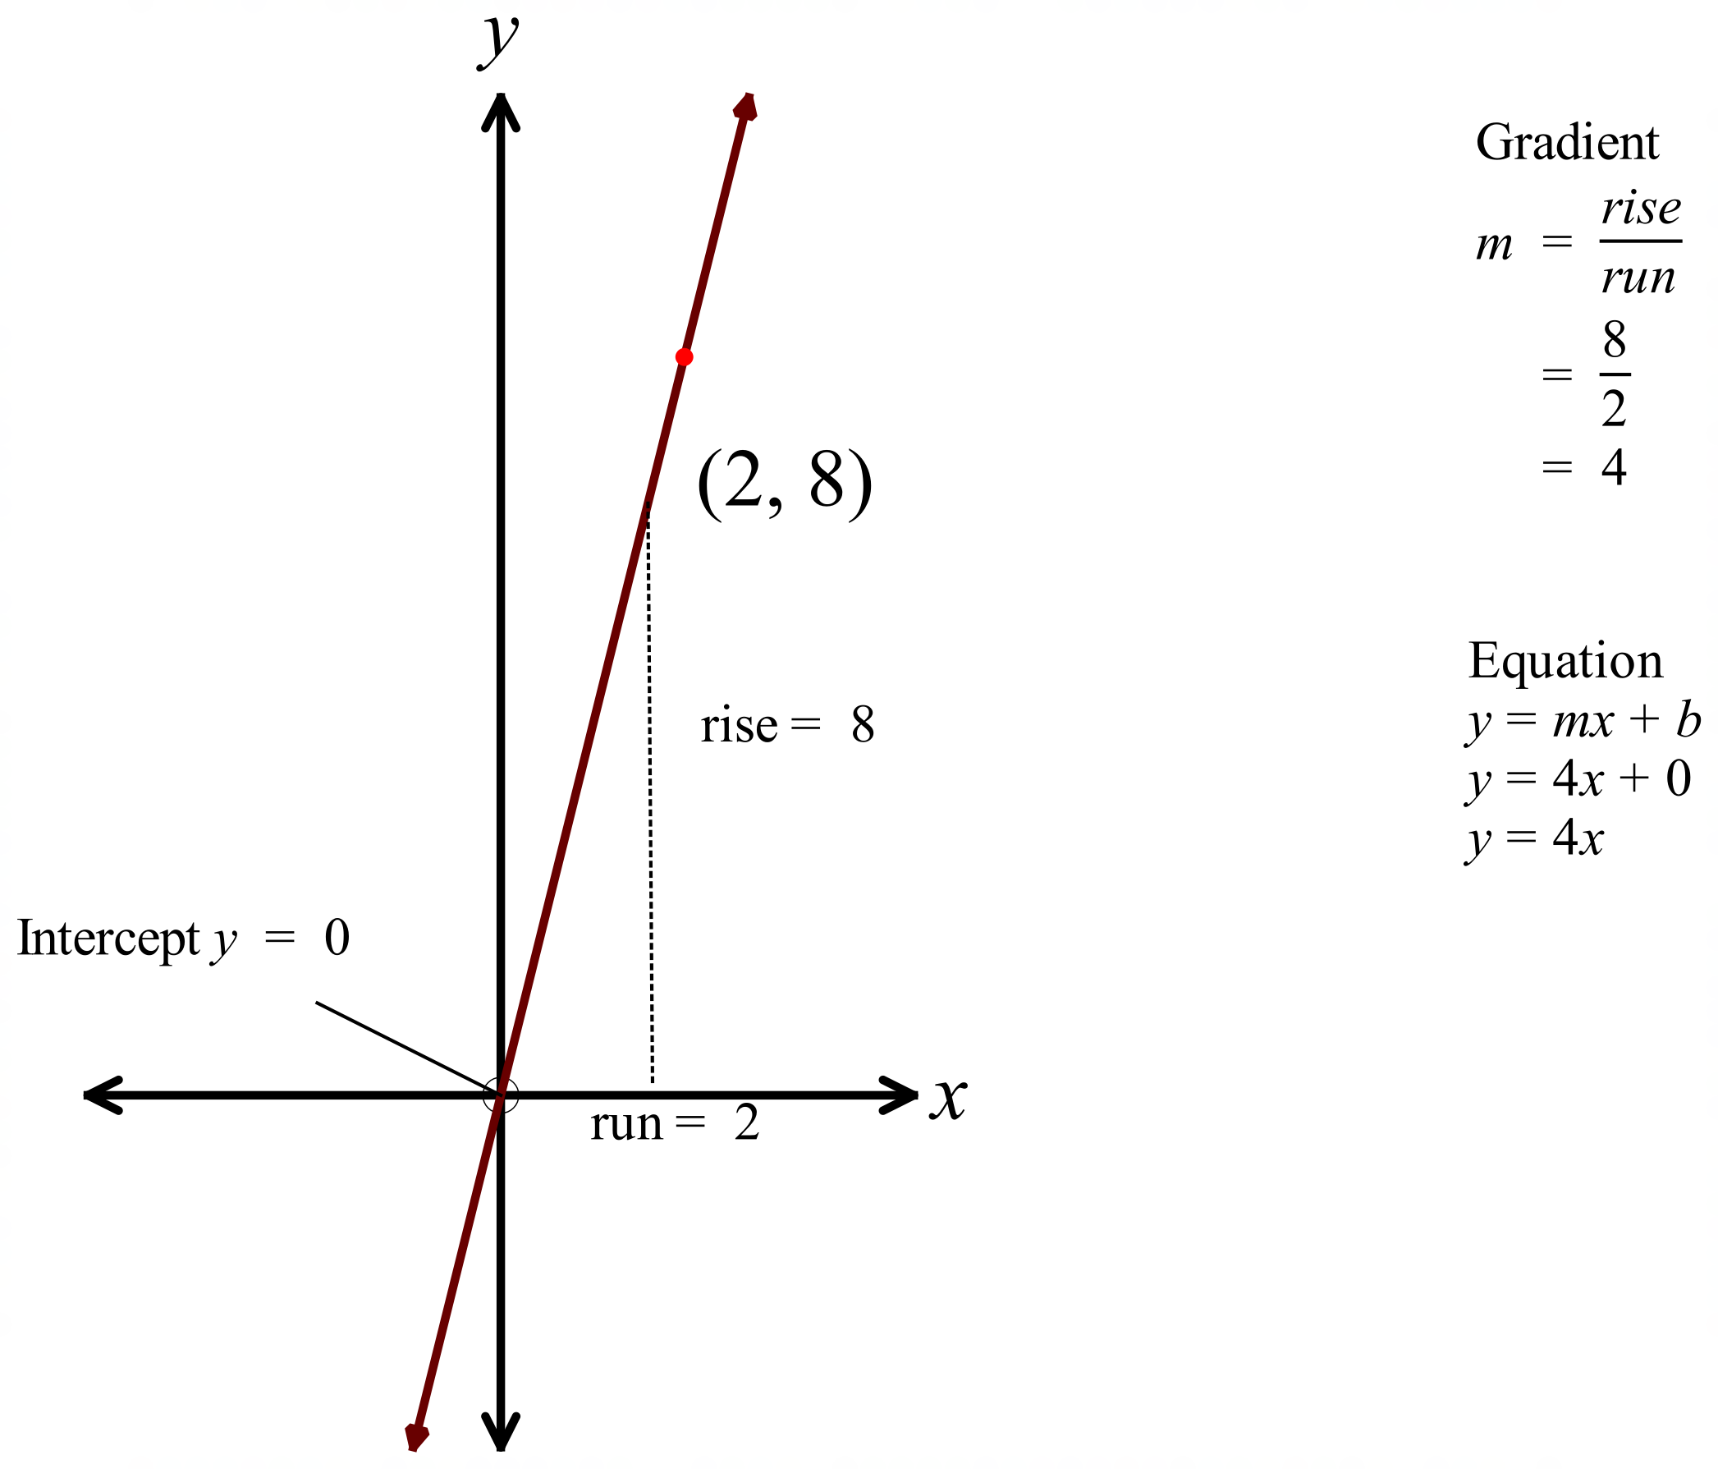
 | 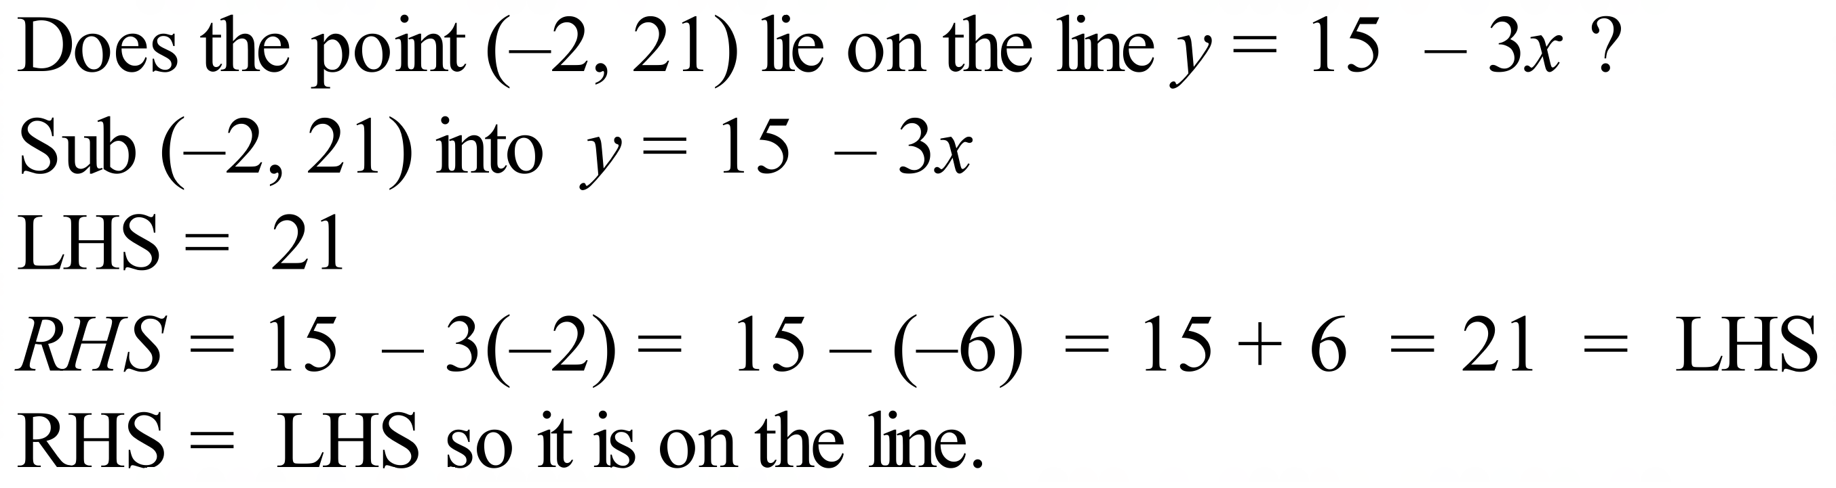
Gradient m = –4 and y intercept b = –9.
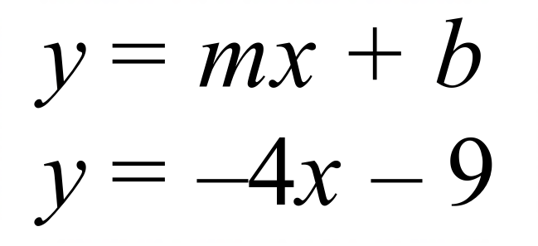
Gradient m = 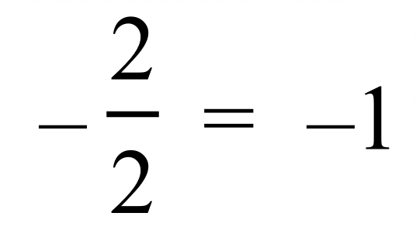 y intercept b = -4
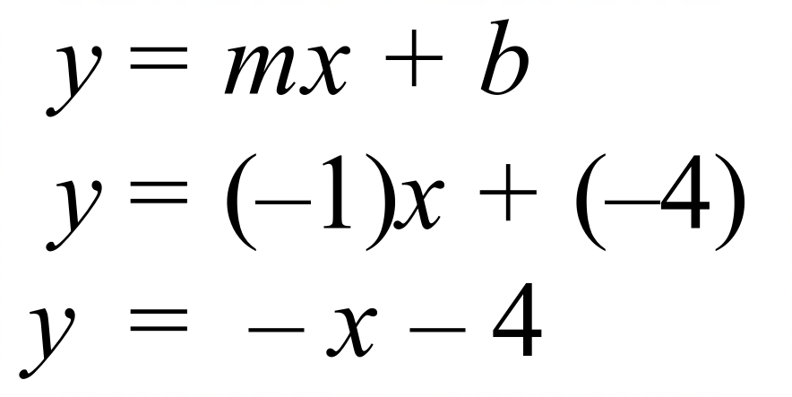
 | 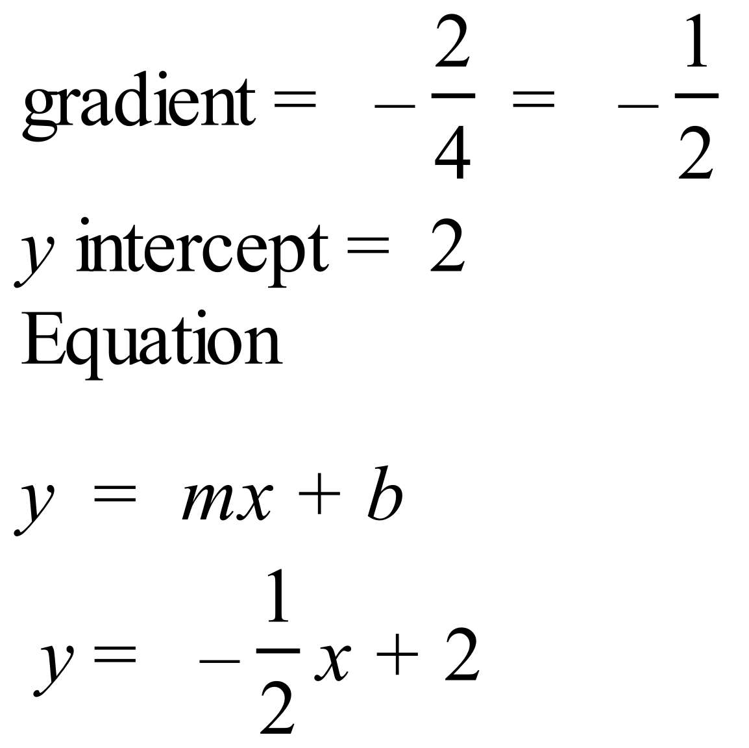
 | 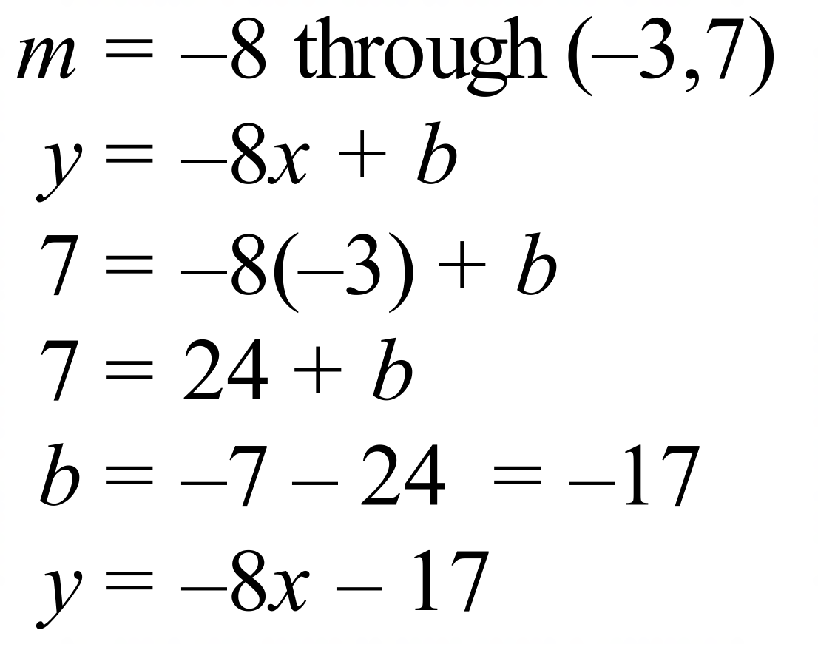
 | 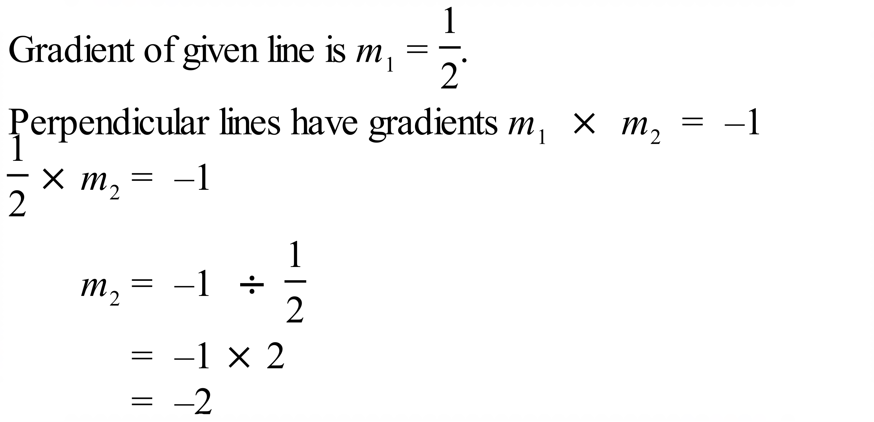
A horizontal line has the same y value for every point on the line.
As the line passes through the point (–7, 9), its equation is y = 9.
 | 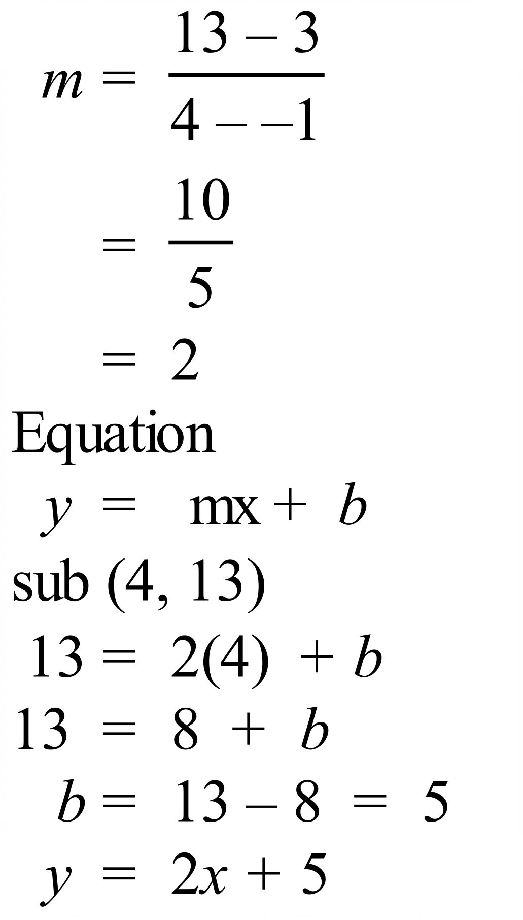
 | 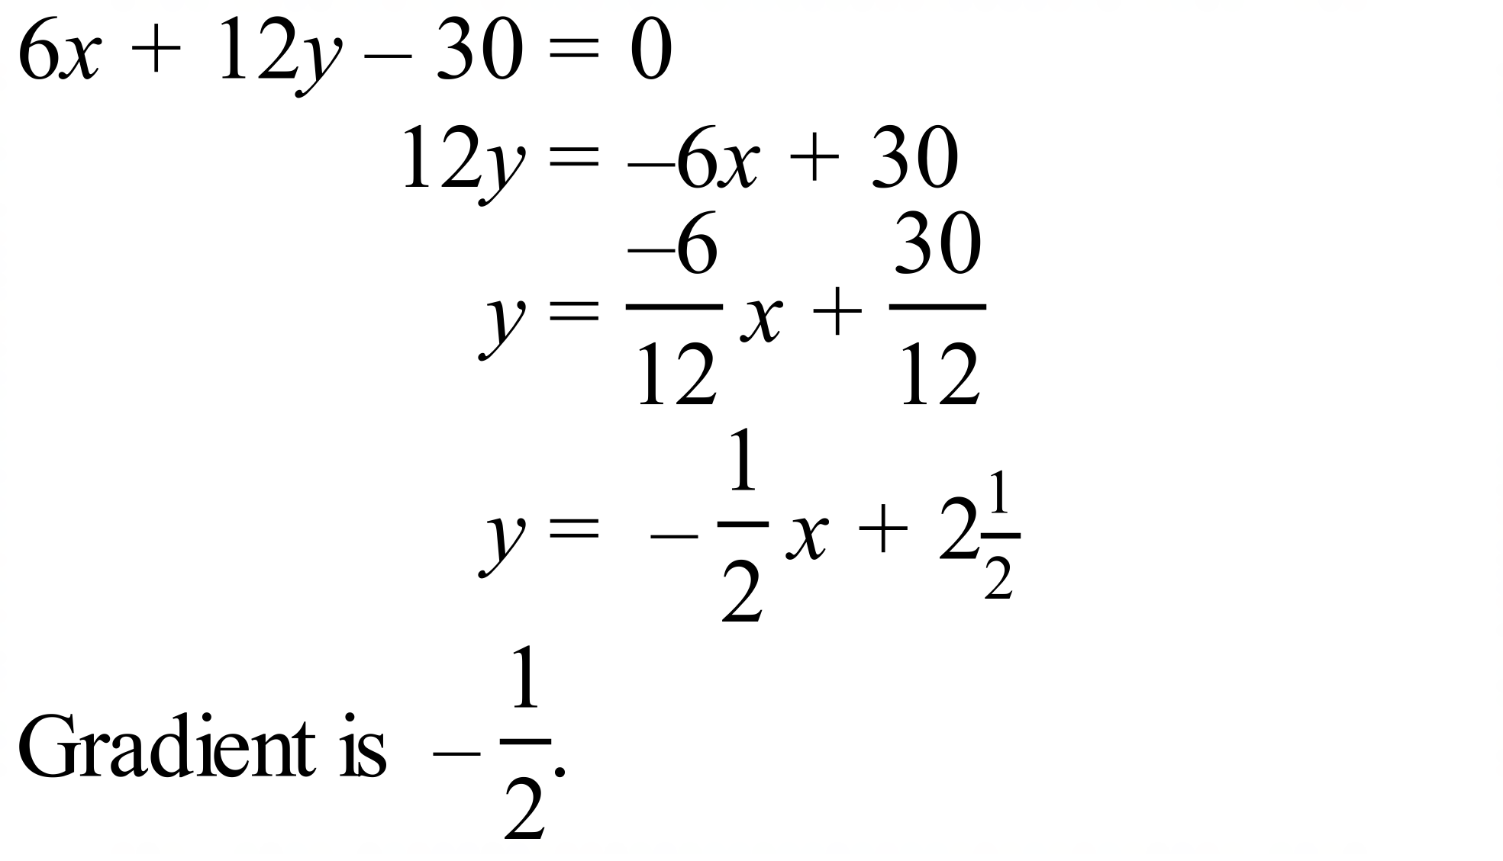
 | 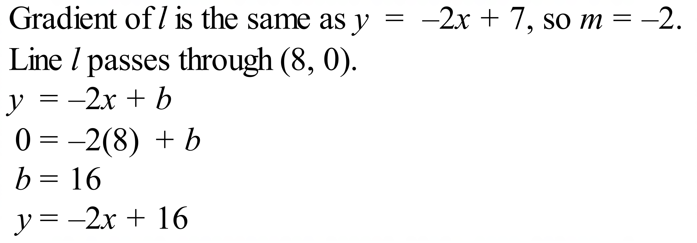
Parallel to the line through (-4, 6).
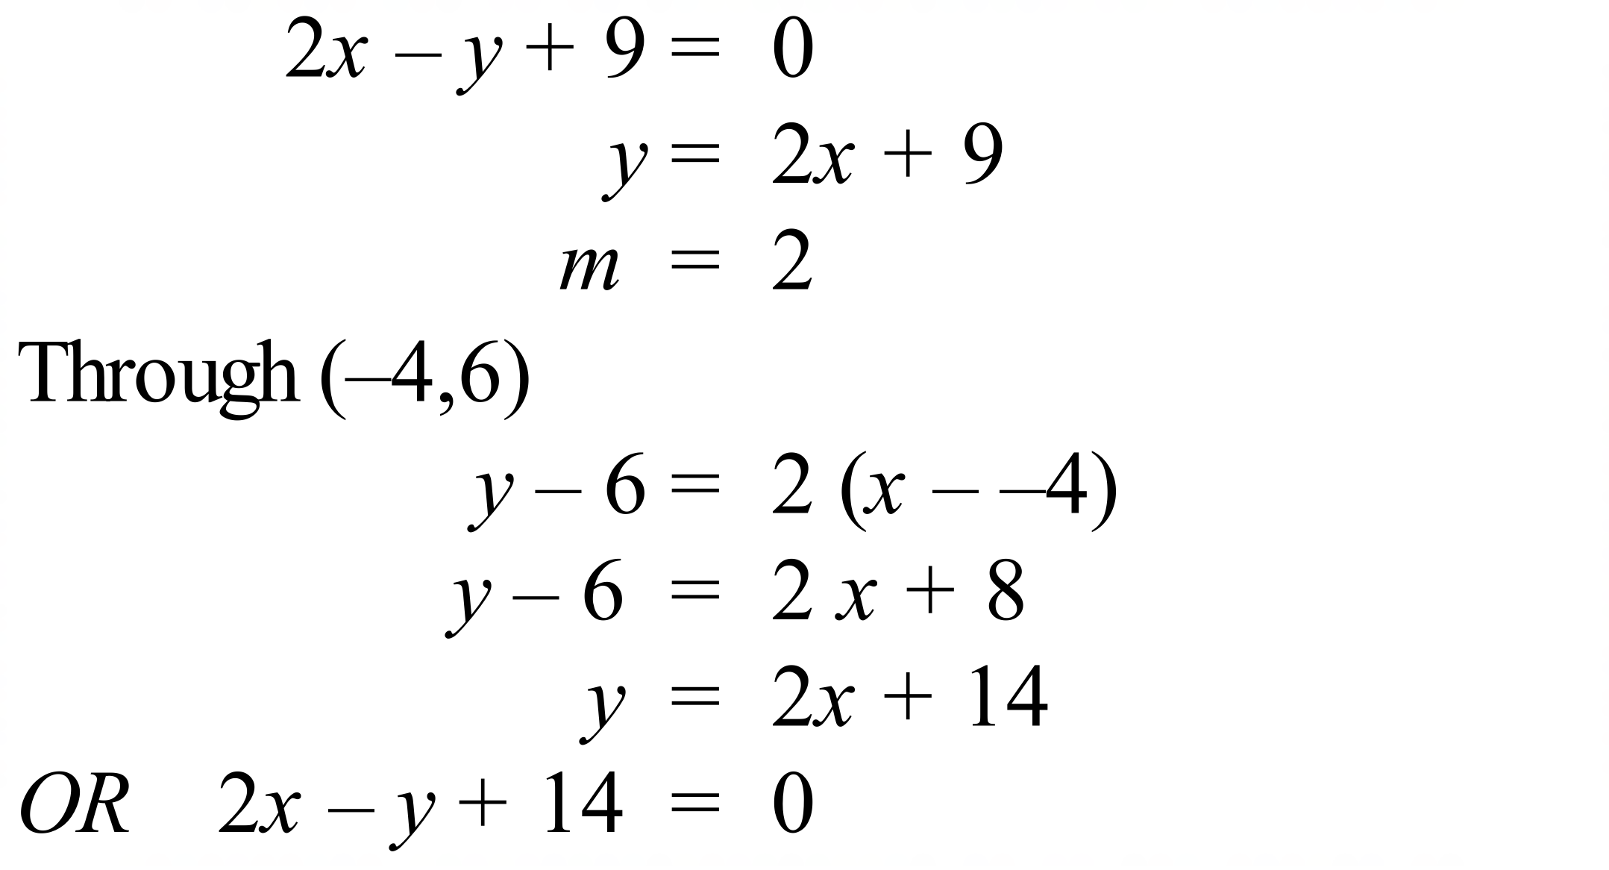
 | 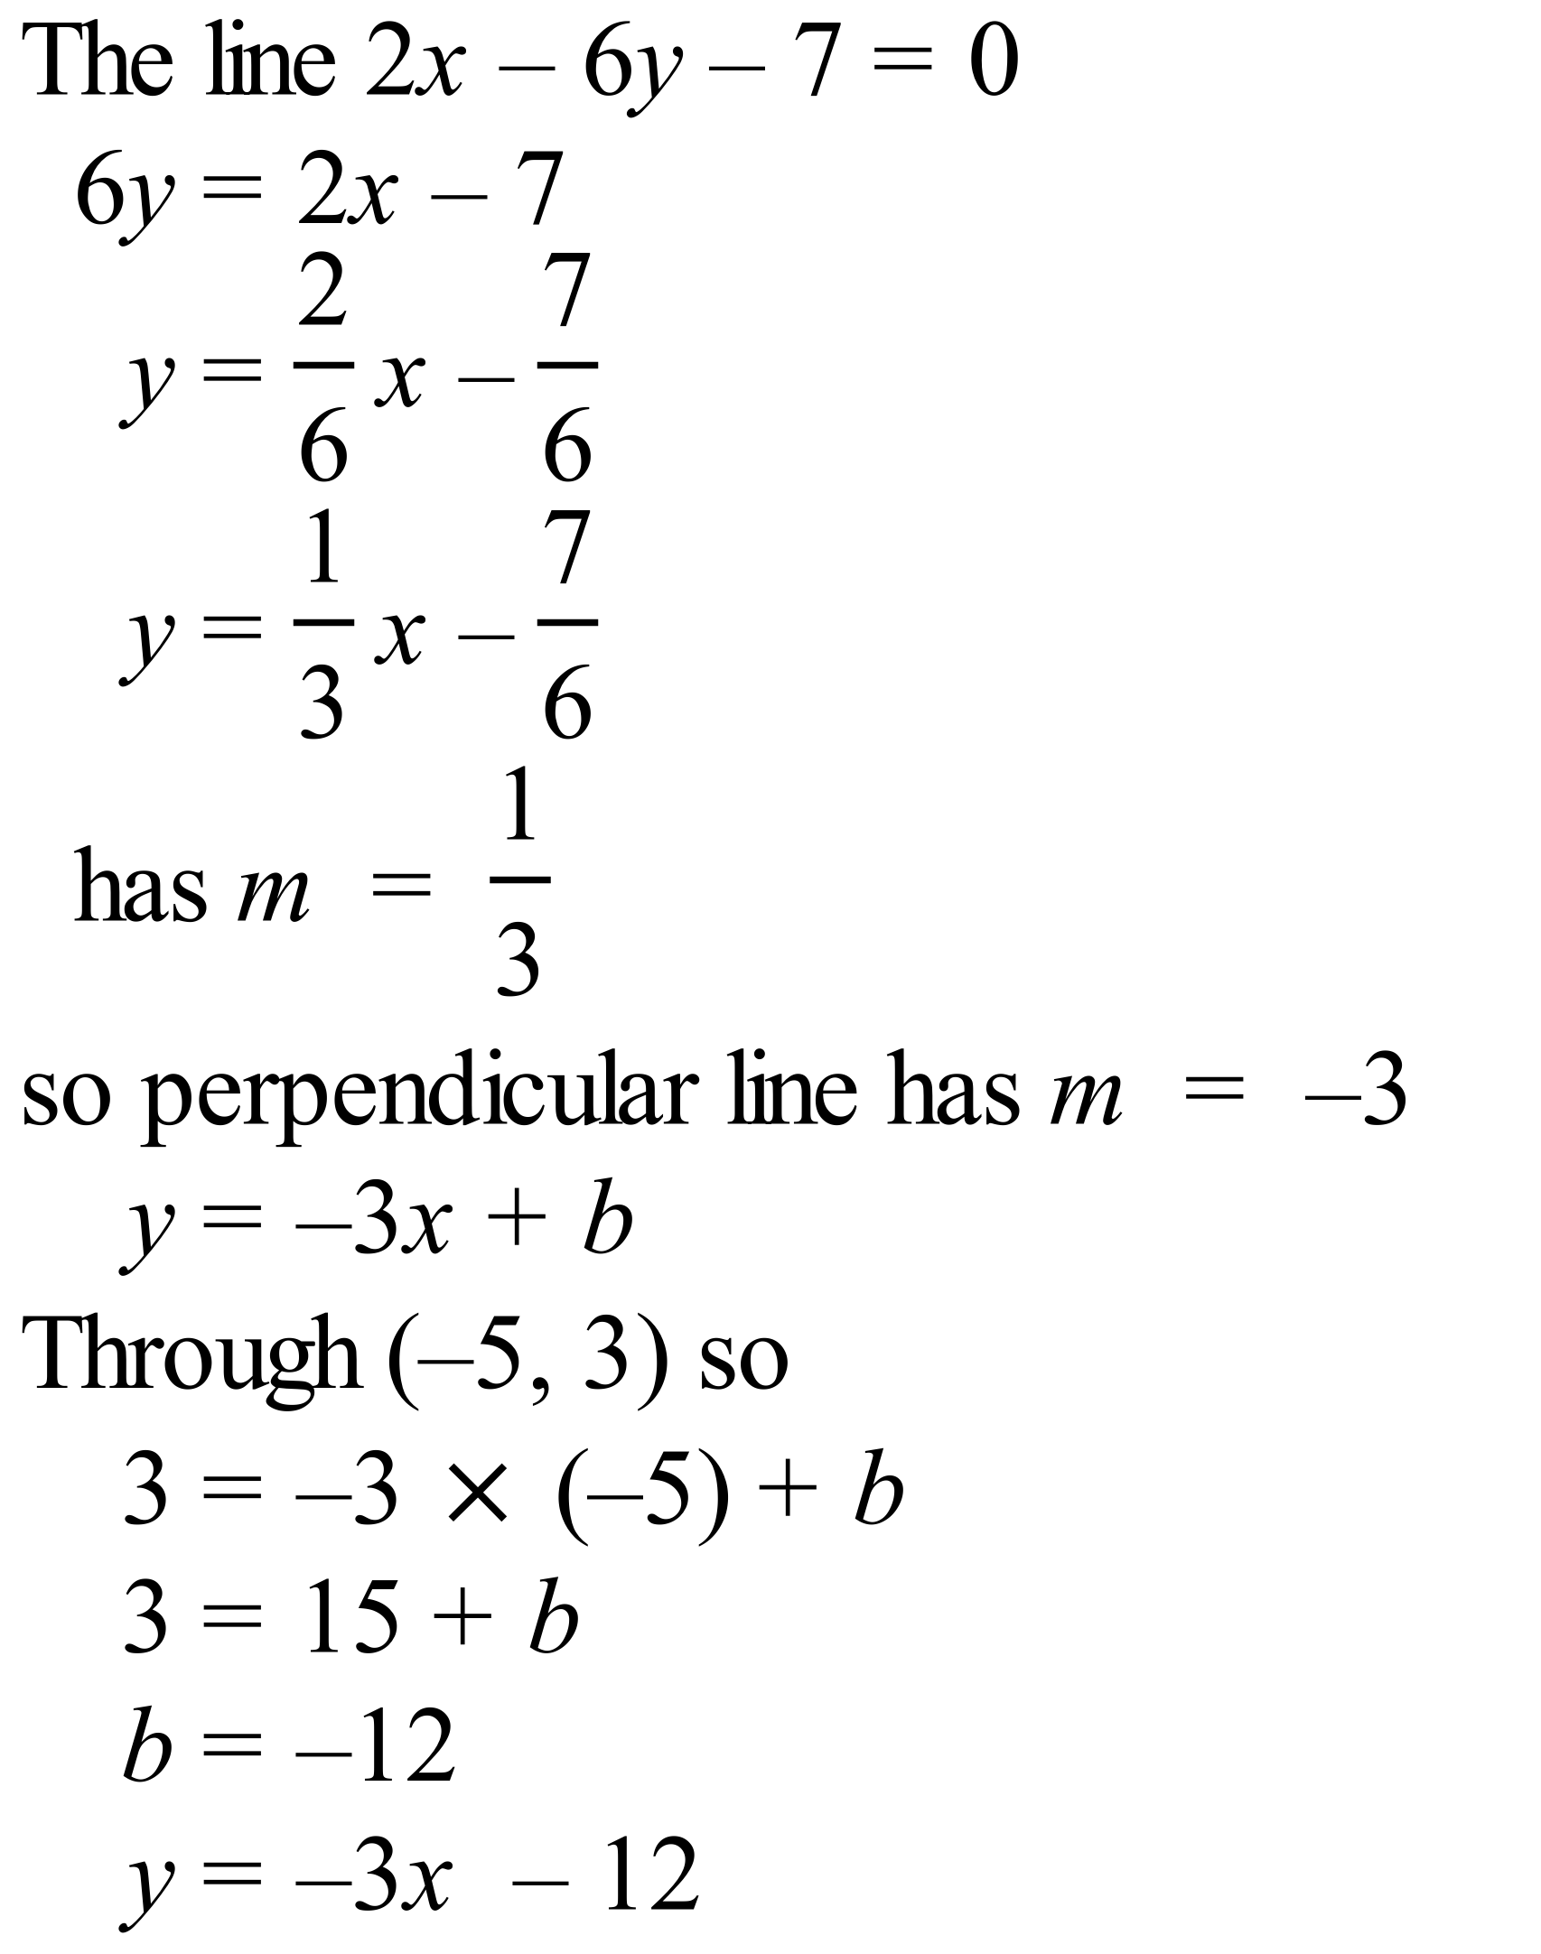

School Name
Mathematics Test 2017
Year 10 | Linear Relations | Calculator Allowed  Multiple Choice  Section

ANSWERS

Question | Working | M C Answer
 | 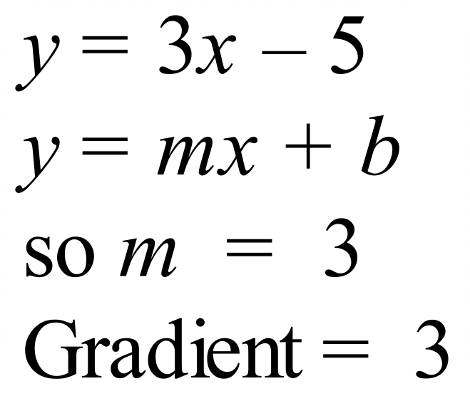 | C
 | 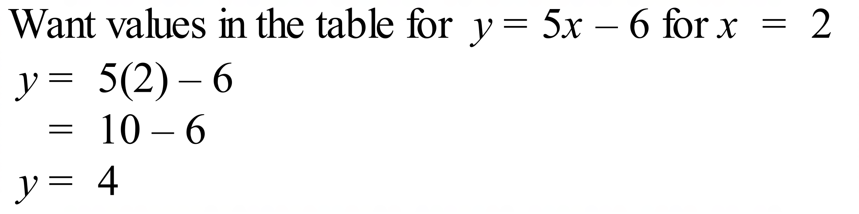 | B
 | Gradient of –2 through –5 on the y axis.  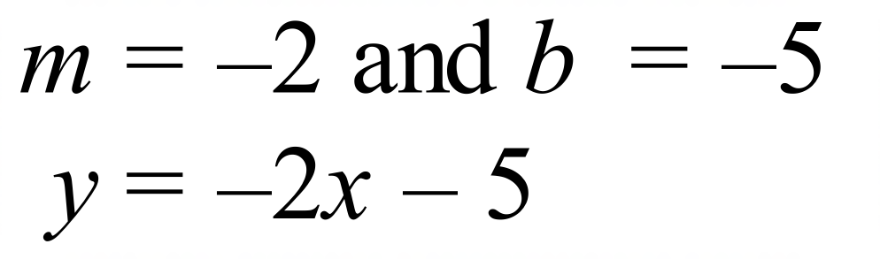 | C
 | 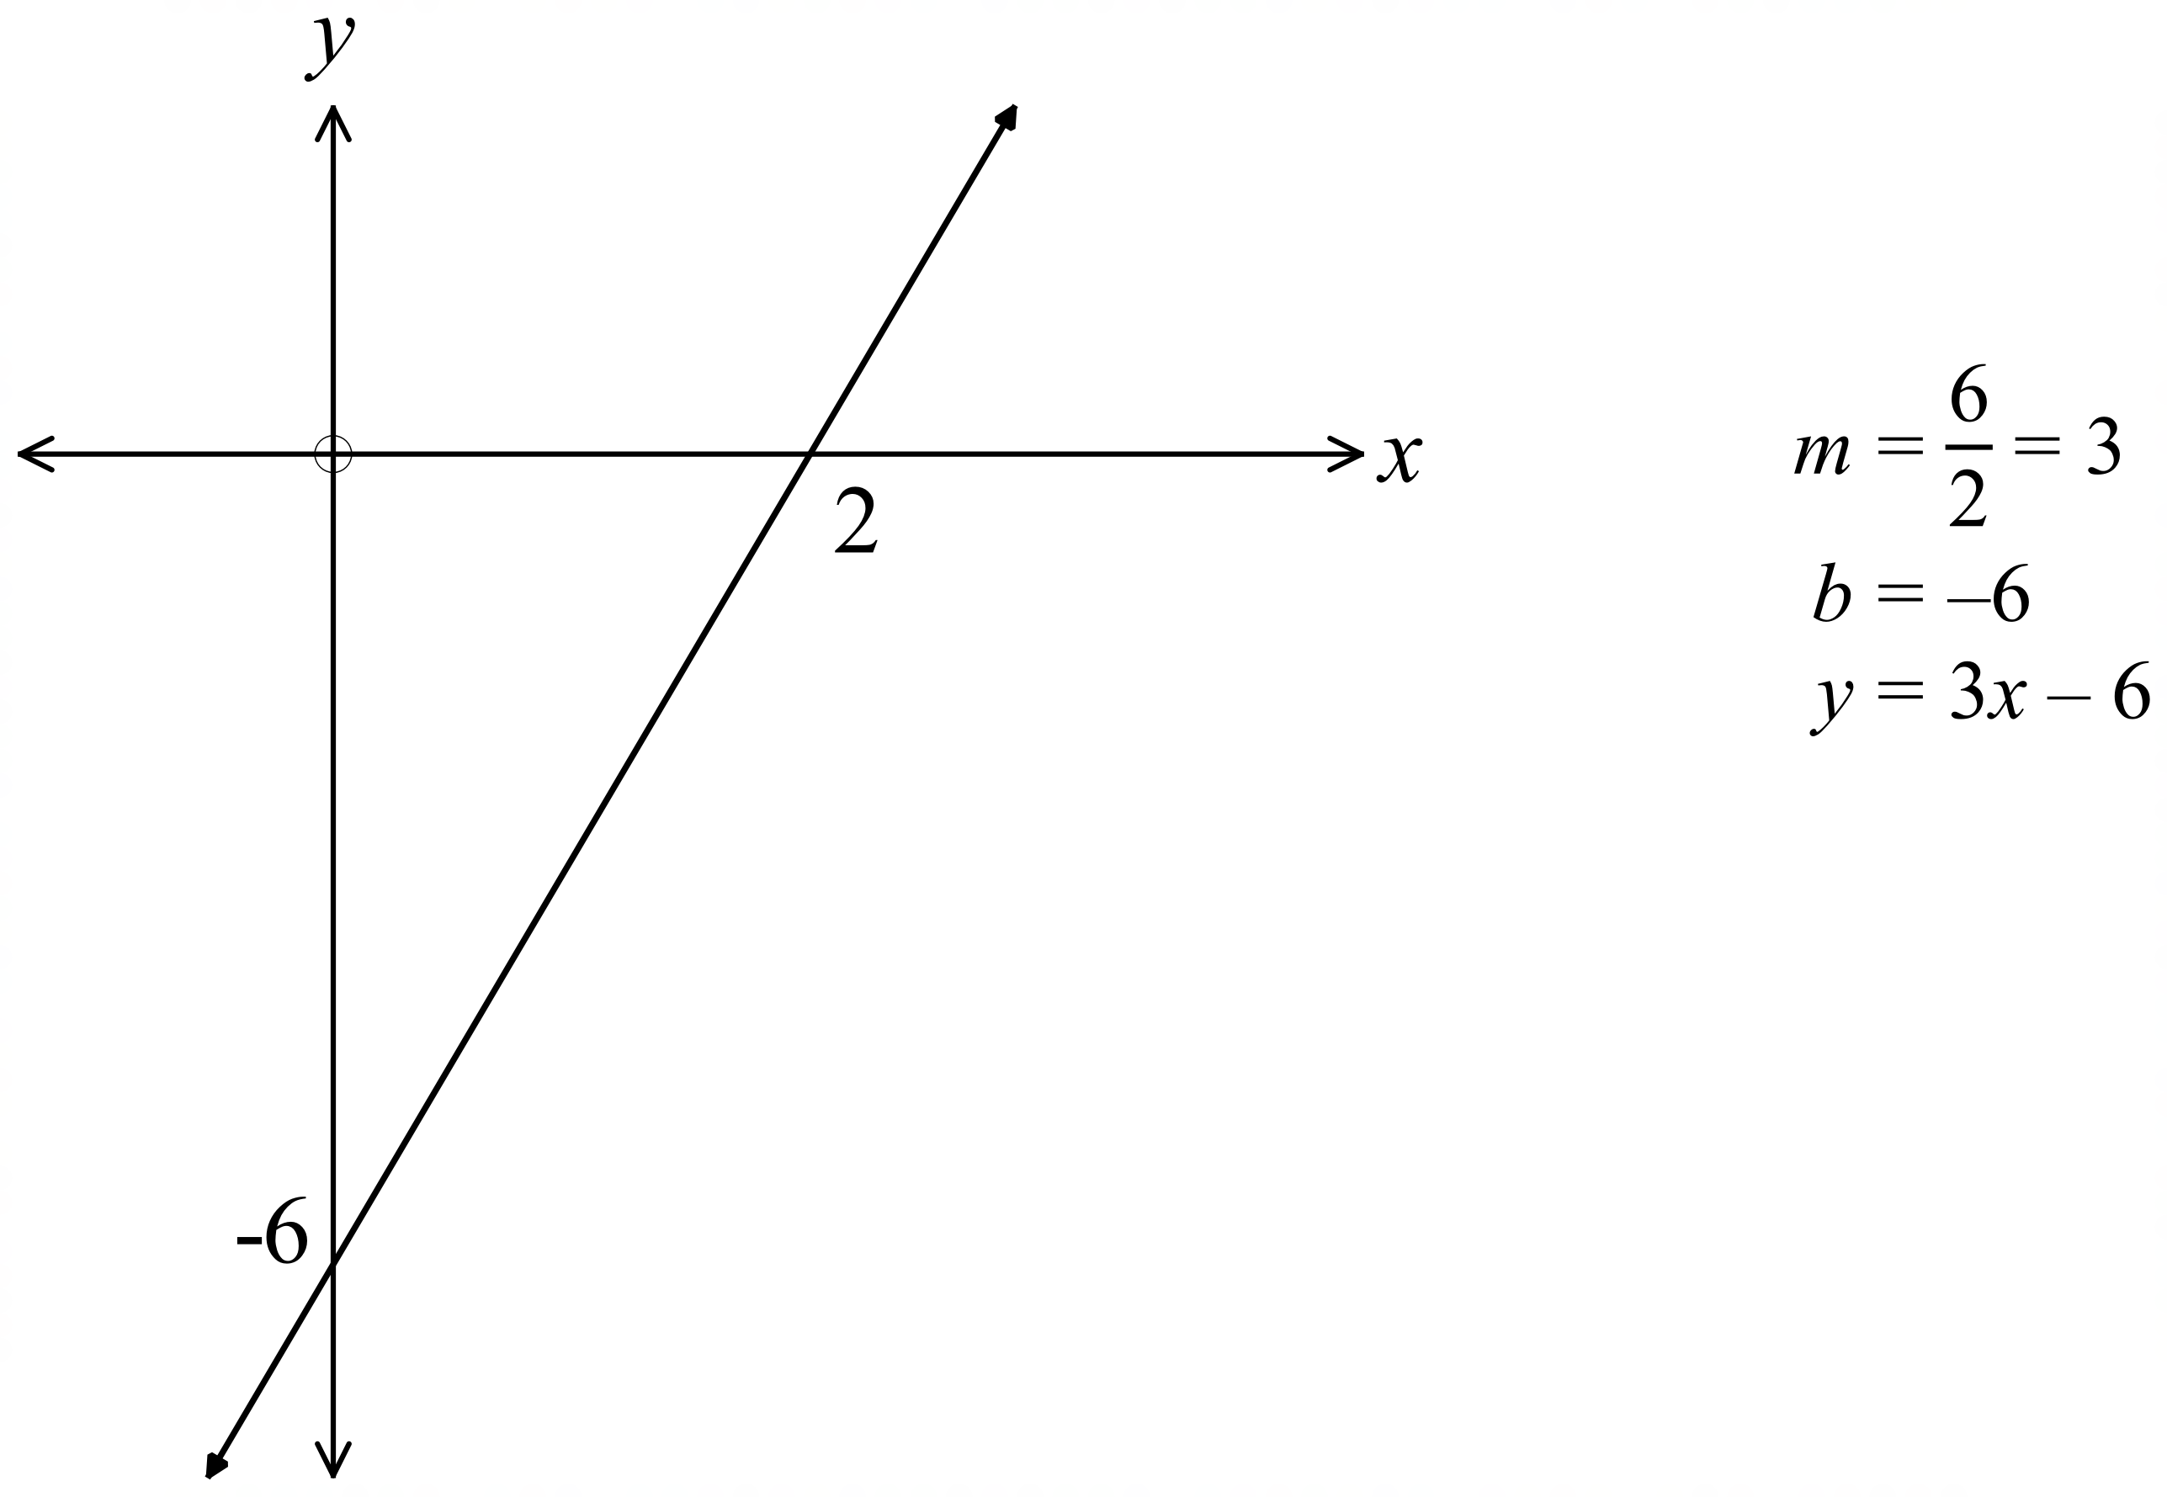 | A
 | 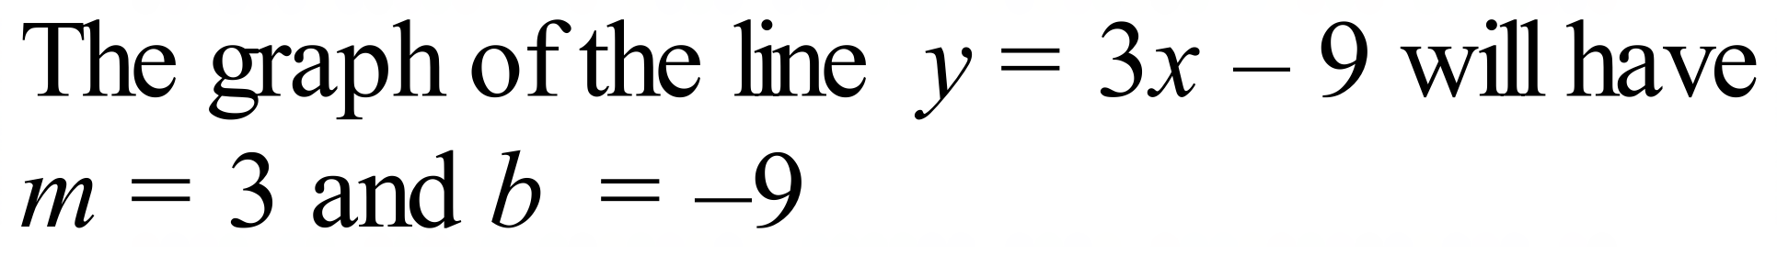 | D
 | 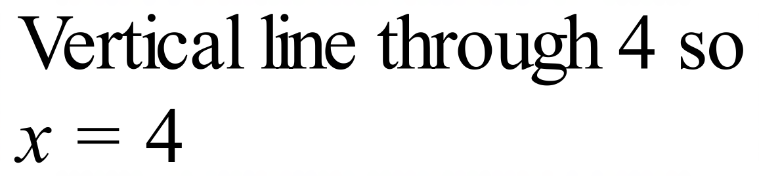 | D
 | Gradient of –6 and passes through the point (–5, 3)  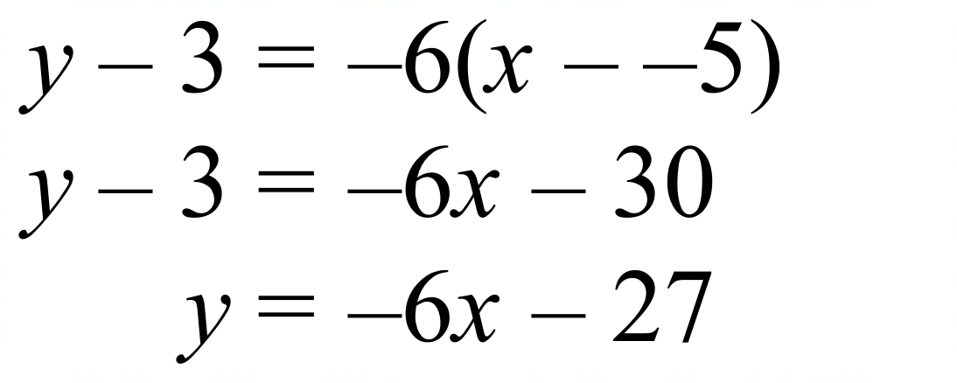 | B
 | Substitute x = –2 into each equation and see if the result is y = –6.  A. 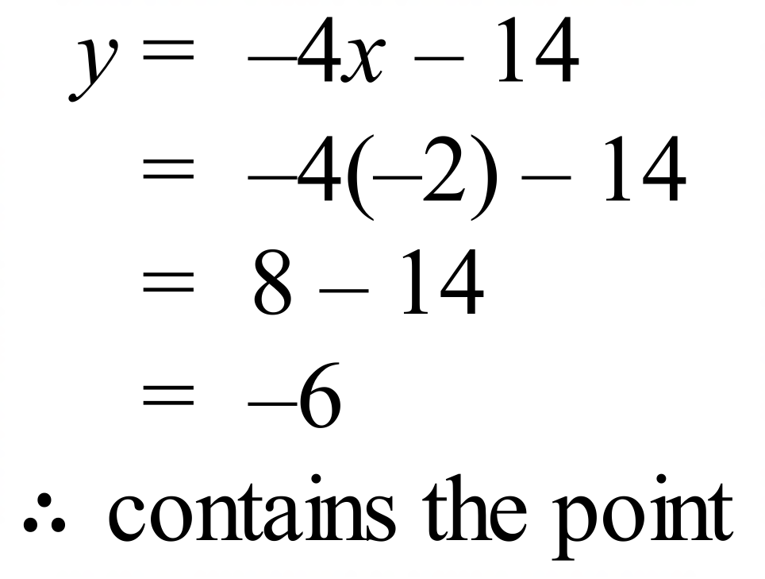 B. 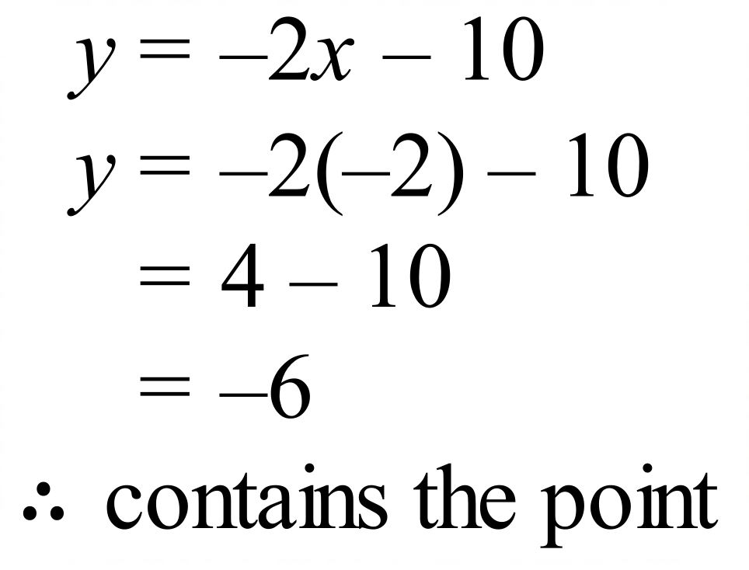  C. 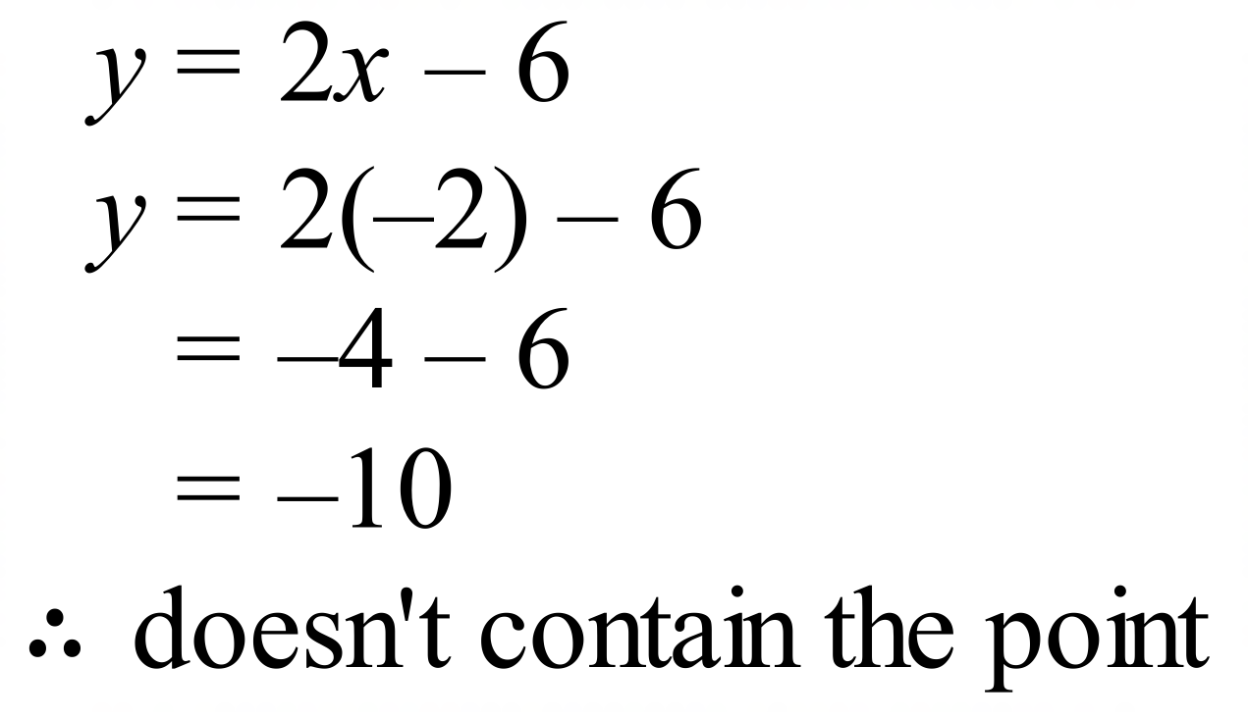 D. 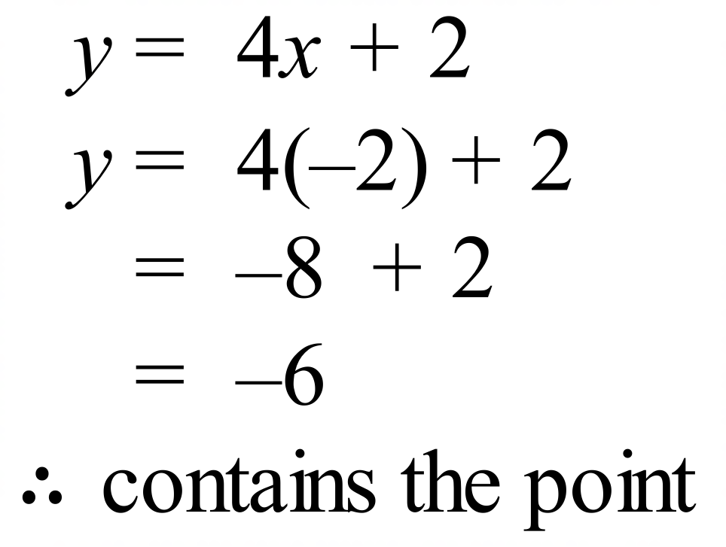 | C
 | 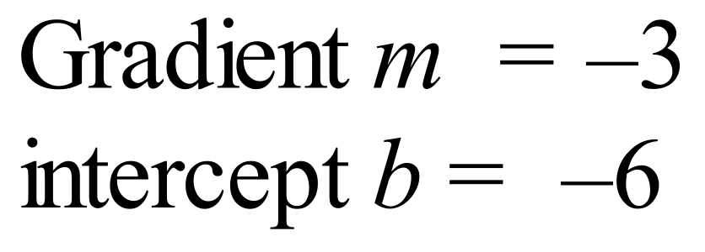 | A
 | 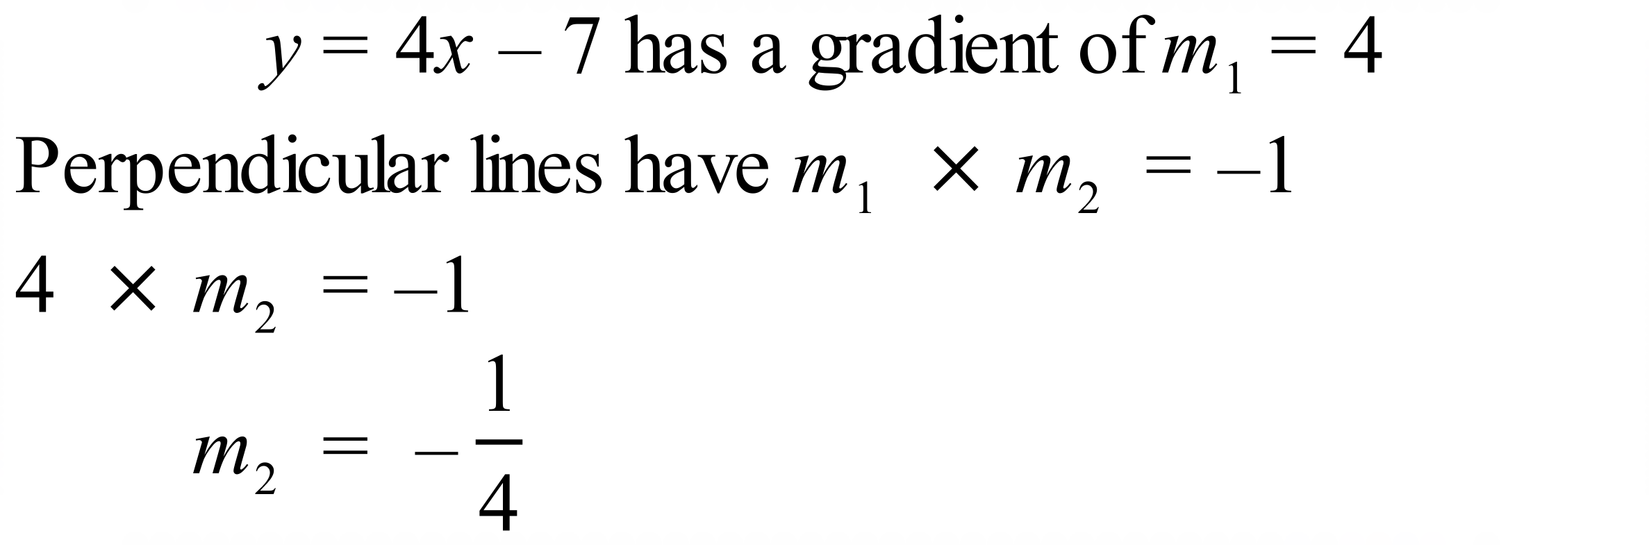  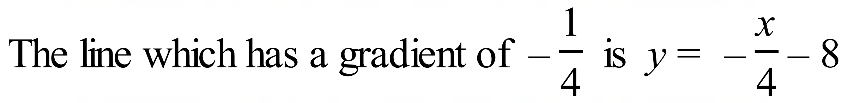 | B
 | 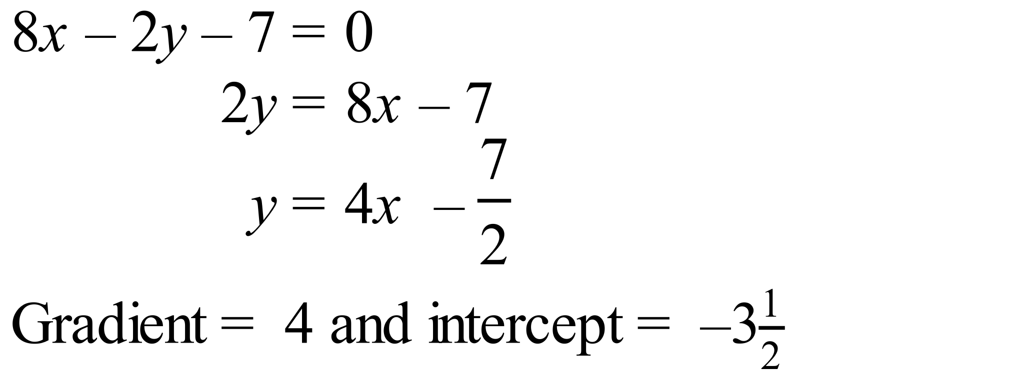 | D
 | For the points (3, –7) and (–1, 1):  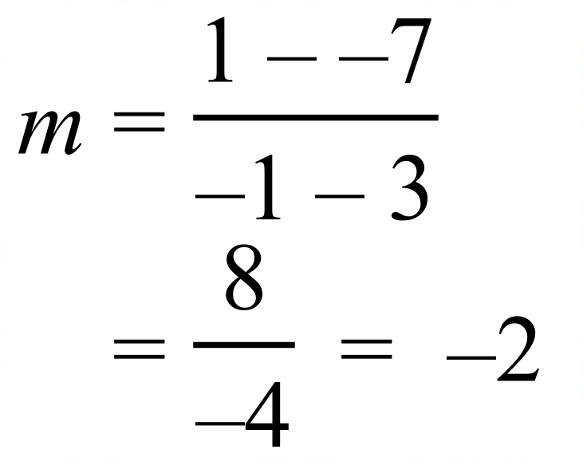  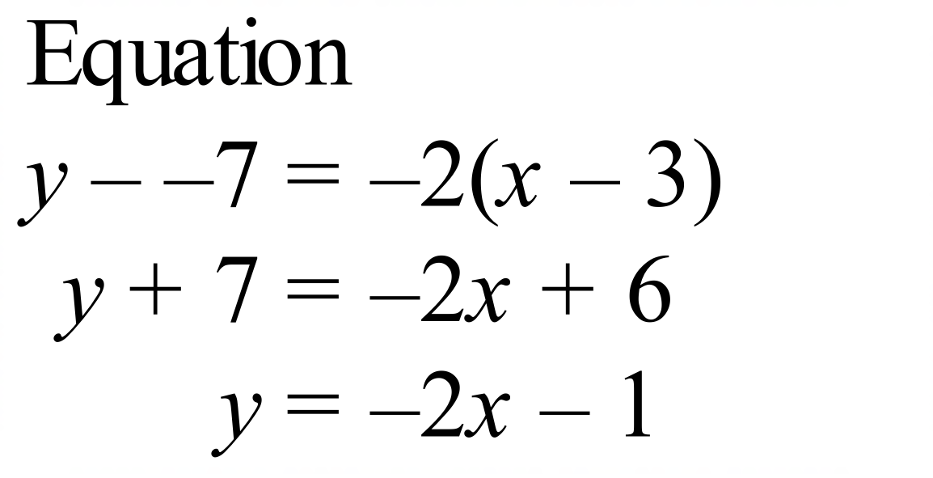 | A
 | Line j has its equation : so 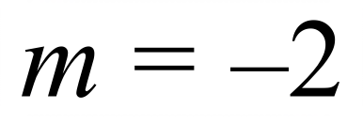  Line k has its equation : 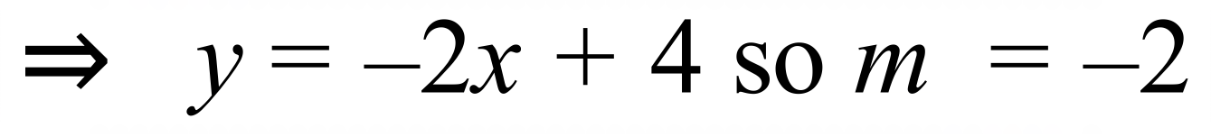  Line l has its equation : 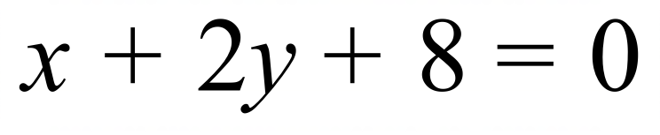 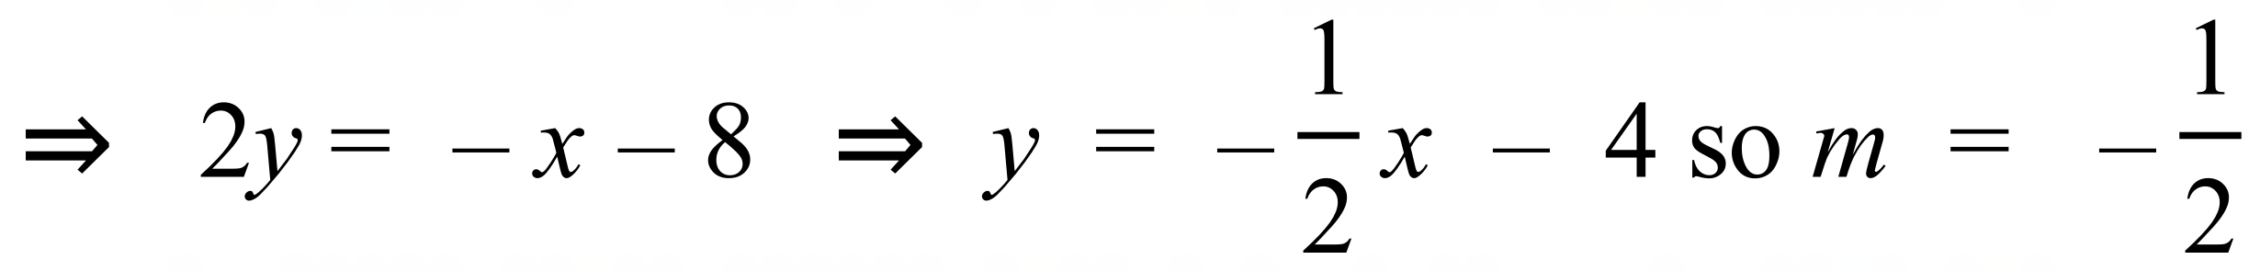  Lines j and k have the same gradient, so are parallel.  No lines are perpendicular as no two gradients have a product of –1. | B
 | 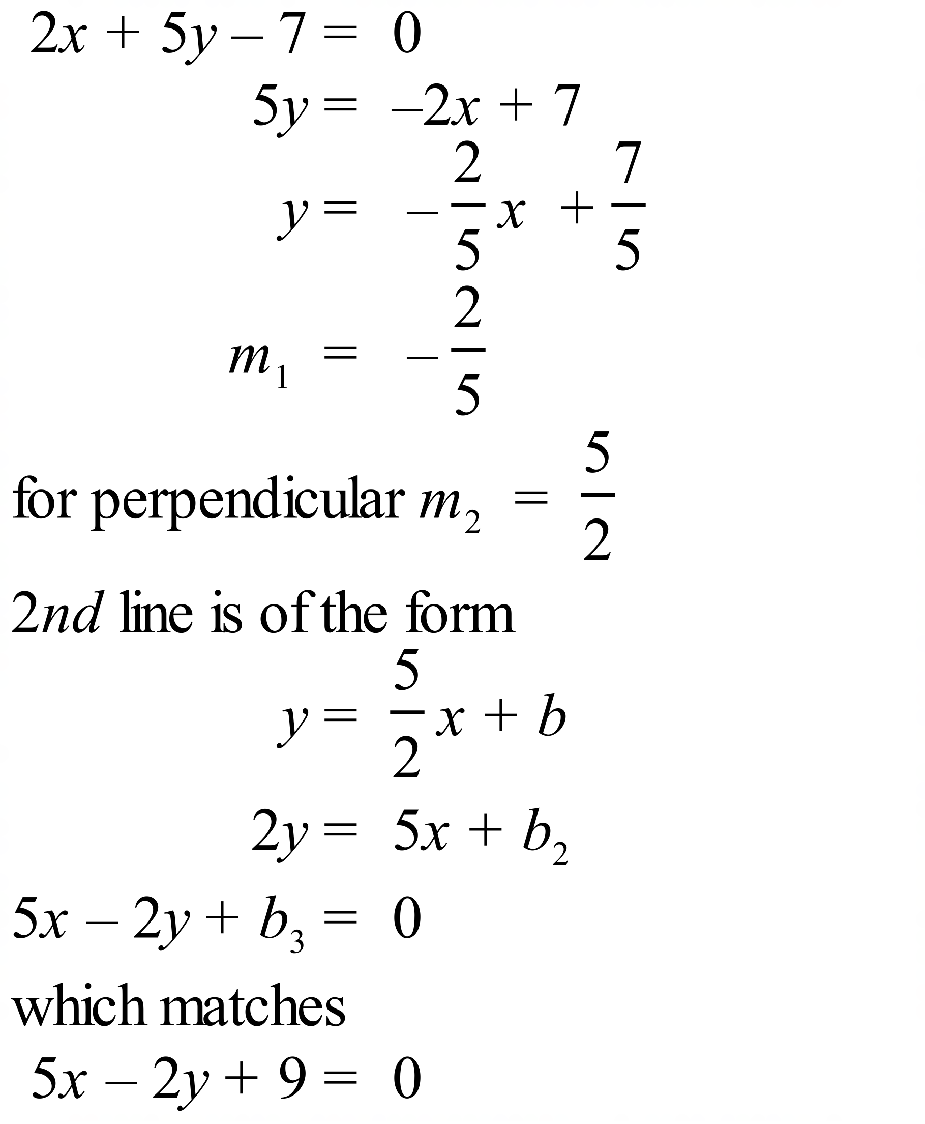 ? | C
 | 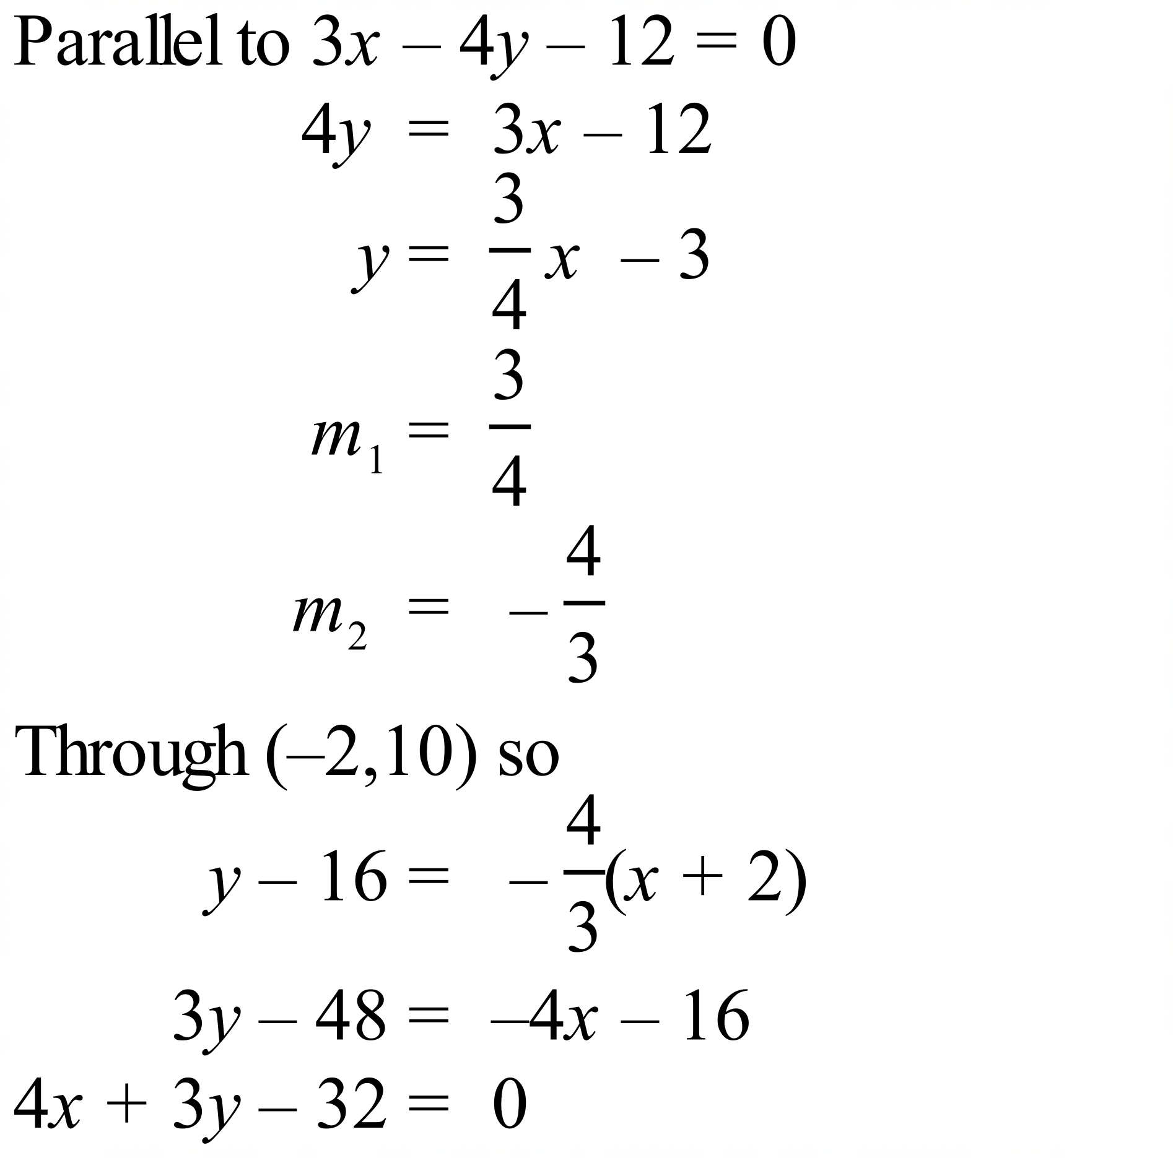 | C

School Name
Mathematics 2017
Multiple Choice Answer Sheet
Linear Relations
Name _____________________________________________
Completely fill the response oval representing the most correct answer.
1. A B C D
2. A B C D
3. A B C D
4. A B C D
5. A B C D
6. A B C D
7. A B C D
8. A B C D
9. A B C D
10. A B C D
11. A B C D
12. A B C D
13. A B C D
14. A B C D
15. A B C D

